Taking a break
Hortence worked in emergency relief operations. “After 10 years I felt myself beginning to respond too slowly to important situations that required quick decision making”, she says. “I felt like I was moving in slow motion. I remember wondering if this was what work-related stress felt like. I didn’t want to find out, so I actually put myself on a break.”
Peer support
In daily life, peer support is important to keeping up spirits and staying well. Peer support can take many forms: maintain contact and socialize with colleagues, share experiences, reactions and concerns, and extend support to each other. 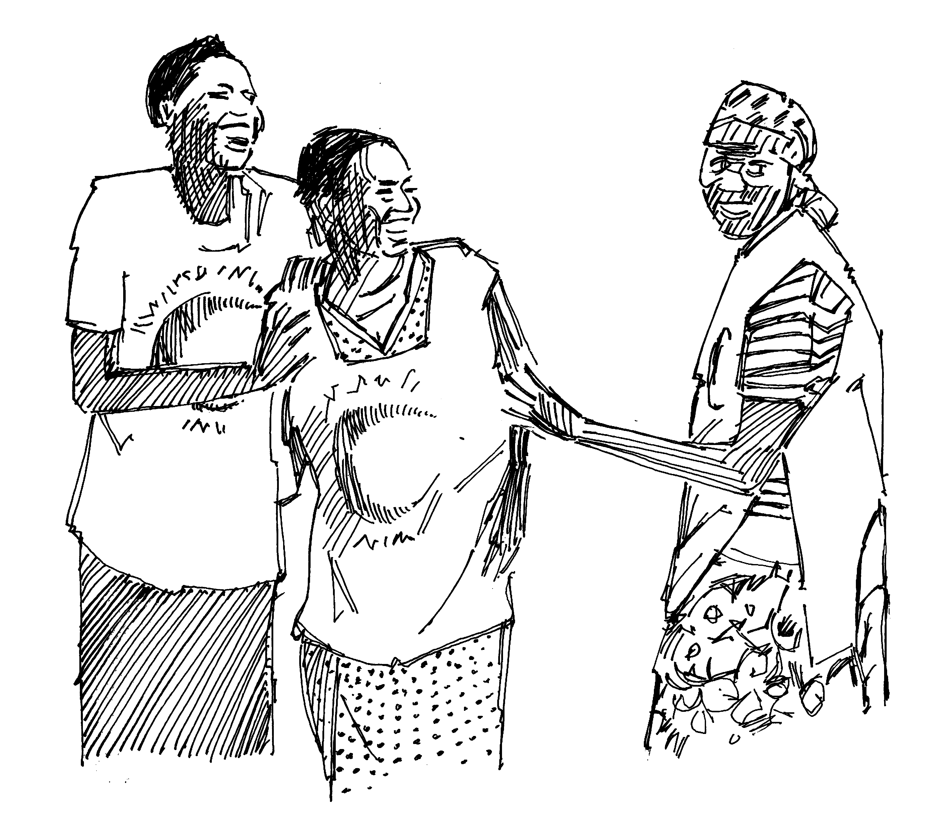
Peer support also involves intervening if a colleague seems distressed or engages in dangerous behaviour. You may approach the person, encourage him or her to seek help and, if necessary, inform your supervisor.
For more information, contact us:
International Federation Reference Centre for Psychosocial Support
Blegdamsvej 27, 2100 Copenhagen,
Denmark
+45 35 25 92 00
http://www.ifrc.org/psychosocial
psychosocial.centre@ifrc.org

Illustrations: Rod Shaw/International Federation
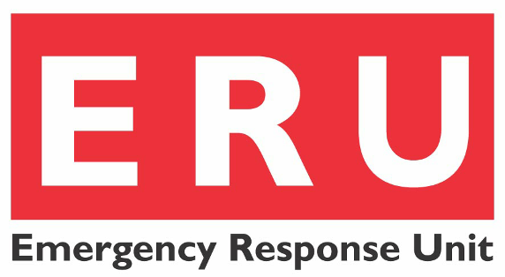

Working in
stressful situations

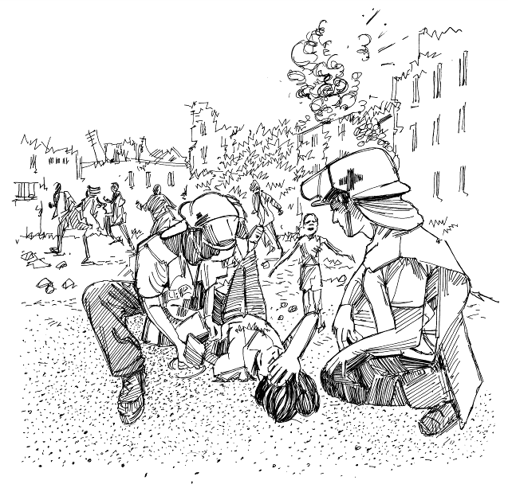

Humanitarian work
Being engaged in humanitarian work following an emergency situation will most often do you well, as it means doing something active and constructive in the midst of a chaotic situation. However, it usually also means working under very stressful conditions.
Humanitarian workers must take care of themselves to avoid stress and stress-related illness.
Stress
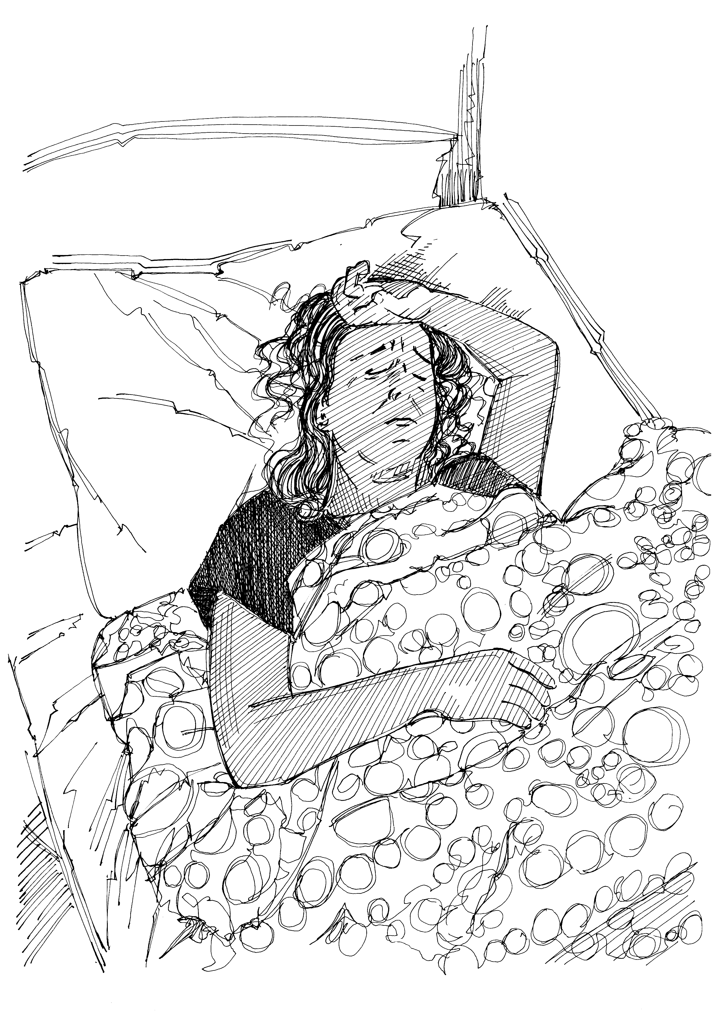
Stress is a state of pressure or strain on body and mind. It can be caused by any change – positive or negative. Stress is an ordinary feature of everyday life and can be positive when it makes a person perform optimally e.g. at an exam. When stress is not managed properly it can seriously affect health, working ability and private life.
Two kinds of work-related stress
When working in emergency or crisis situations, it is important to be aware of two kinds of work-related stress: critical incident stress and cumulative stress.
Critical incident stress may be caused by exposure to e.g. sudden danger to self or others, whether perceived or real, exposure to violent actions or multiple deaths, death of a colleague, hostage taking, and direct or indirect threats or assault of any kind.
Cumulative stress may be caused by prolonged exposure to stressful situations, working too much for too long, having to carry out difficult or exhausting tasks, poor preparation and briefing, lack of debriefing and moral support, and being cut off from private support systems if working away from home. Some humanitarian workers suffer from stress reactions because they are not able to meet needs of beneficiaries or are facing moral or ethical dilemmas in connection with their work
Common signs of stress
It is normal for human beings to react when experiencing an abnormal situation. This is important to remember when experiencing stress reactions.
When suffering from stress, people frequently experience one or more of the following: sleep disturbances; somatic symptoms such as stomach pains, headaches, chest pains or rapid heart beat; anxiety; chronic fatigue or loss of energy; concentration problems; lack of appetite; or apathy. Some experience changes in their mood or behaviour resulting in irritability, sudden mood swings, depression or cynicism; or take on self-induced isolation or behaviour that is either over-cautious or risk-taking.
Preventing and managing stress
In order to prevent and manage stress, it is important to understand that stress is a normal human reaction to an abnormal situation. In order to facilitate your own coping, identify major stress factors and develop a plan of how to avoid them. Eat healthy foods, get exercise, avoid working too much, talk about your experiences and reactions with colleagues, and maintain contact with friends and family at home. It may be helpful to make a self-care plan, possibly in cooperation with someone else for inspiration.
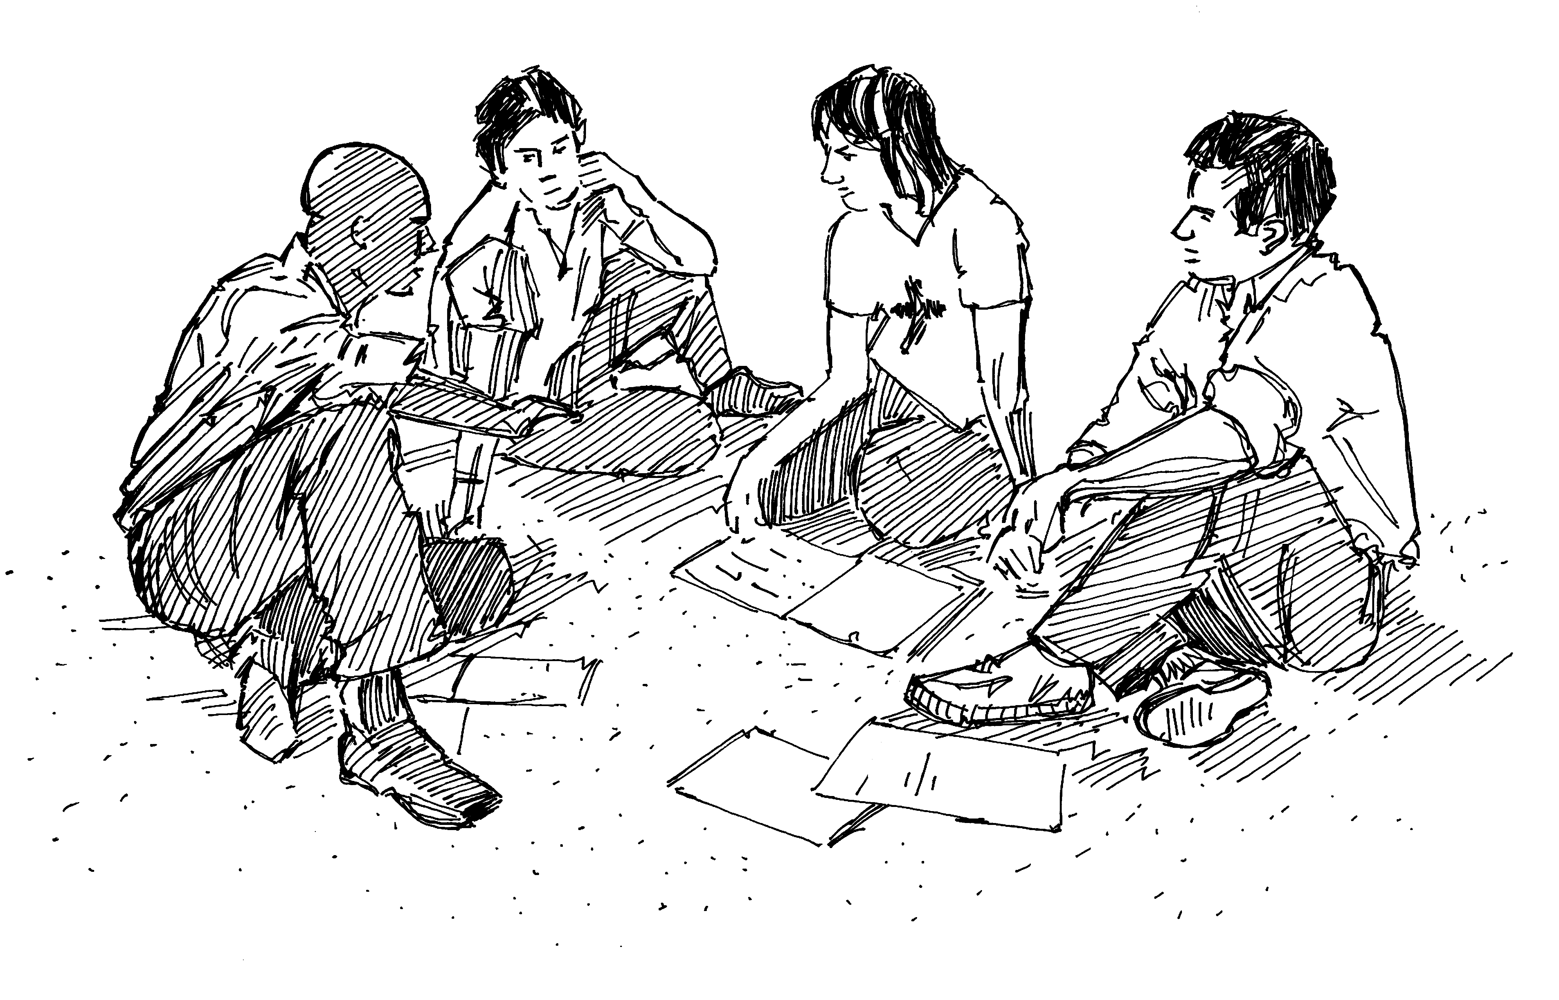
You should take part in any briefing and information sharing sessions which are organized for you, and also participate in all debriefing sessions which may be organized, as this is of great value in terms of avoiding stress. If a critical incident has taken place, encourage the organization of stress debriefing sessions with team members.

