This working paper is a collective effort of a diverse group of professionals and volunteers to pull together the most salient issues in care and support for spontaneous unaffiliated volunteers. The hope is that the knowledge, thought leadership, practical tools, case examples and recommendations collected here will contribute to supporting both crisis managers, policy makers and practitioners to provide good care and support for spontaneous unaffiliated volunteers.
The single most important point made in this working paper is that it is imperative that crisis management fulfils its duty of care towards spontaneous unaffiliated volunteers. What this looks like in practice will differ significantly from one organization to another, from country to country and from community to community. But the spontaneous unaffiliated volunteers are always there. The care and support they need must be there too.
A WORKING PAPER AND TOOLBOX FOR CARE AND SUPPORT FOR SPONTANEOUS UNAFFILIATED VOLUNTEERS

NEW WAYS OF VOLUNTEERING. CHALLENGES AND OPPORTUNITIES

Martha Bird and Louise Juul Hansen, IFRC Reference Centre for Psychosocial Support
January 2020
TABLE OF CONTENTS
EXECUTIVE SUMMARY 5
ACKNOWLEDGEMENTS 6
INTRODUCTION 7
WHO IS THIS WORKING PAPER FOR? 7
HOW TO READ THIS WORKING PAPER 7
WHO IS BEHIND THIS WORKING PAPER? 8
WAYS TO DESCRIBE AND UNDERSTAND SPONTANEOUS UNAFFILIATED VOLUNTEERS 9
AFFILIATION 9
TIME 10
LOCATION 10
STRUCTURE 11
THE CHALLENGES AND BENEFITS OF CARING, SUPPORTING AND PROTECTING SPONTANEOUS UNAFFILIATED VOLUNTEERS 12
CASE EXAMPLE: EMOTIONAL CHALLENGES FACED BY SPONTANEOUS UNAFFILIATED VOLUNTEERS PROTECTING A STUDENT CLUB FROM FLOODS 12
BENEFITS OF INVOLVING SPONTANEOUS UNAFFILIATED VOLUNTEERS IN DISASTER RESPONSE 13
CHALLENGES AND RISKS OF INVOLVING SPONTANEOUS UNAFFILIATED VOLUNTEERS IN DISASTER RESPONSE 14
DESIGNING POLICIES THAT WORK FOR SPONTANEOUS UNAFFILIATED VOLUNTEERS – OPPORTUNITIES AND RECOMMENDATIONS 16
CURRENT STATE OF PLAY: GLOBAL FRAMEWORKS FOR WORKING WITH VOLUNTEERS IN CRISIS 16
CASE EXAMPLE OF GOOD INTEGRATION OF SPONTANEOUS UNAFFILIATED VOLUNTEERS IN EMERGENCY RESPONSE STRUCTURES: THE COMMONWEALTH OF AUSTRALIA’S POLICY ON SPONTANEOUS VOLUNTEERS 17
RECOMMENDATIONS FOR THE FUTURE 18
OPERATIONAL CONSIDERATIONS FOR CARE AND SUPPORT OF SPONTANEOUS UNAFFILIATED VOLUNTEERS 21
DIFFERENT NEEDS FOR CARE AND SUPPORT FOR LOCAL AND NON-LOCAL VOLUNTEERS 21
CASES 21
FLOOD RESPONSE IN JYLLINGE, DENMARK 21
LESSONS 22
TERROR INCIDENT IN TEL-AVIV, ISRAEL 22
LESSONS 23
RECOMMENDATIONS 23
OVERALL RECOMMENDATIONS FOR SUPPORTING SPONTANEOUS UNAFFILIATED VOLUNTEERS BEFORE, DURING AND AFTER EVENTS 24
LEARNING FROM PUBLISHED GUIDELINES 25
DIGITAL VOLUNTEERS 28
ABOUT THE DIGITAL VOLUNTEER 28
INFORMATION SEEKING, SENSE-MAKING AND TECHNOLOGY 31
BENEFITS OF USING DIGITAL VOLUNTEERS IN CRISES 31
CASES 33
VOST PORTUGAL (CYCLONE IDAI RESPONSE 2019, MOZAMBIQUE) 33
LESSONS 33
VOST PORTUGAL FUEL CRISIS APRIL/AUGUST 2019 34
LESSONS 34
HUMANITY ROAD RESPONSE TO AMATRICE EARTHQUAKE (CENTRAL ITALY, 2016) 34
LESSONS 35
CHALLENGES AND OPEN ISSUES CONCERNING DIGITAL VOLUNTEERS 35
LACK OF PHYSICAL PROXIMITY 35
ENGAGEMENT 35
TRUST 35
LACK OF SUPPORT 36
DISCONNECTION 36
A WAY FORWARD: RECOMMENDATIONS FOR POLICY ON DIGITAL VOLUNTEERS 37
TOOLS TO AID IMPLEMENTATION OF CARE AND SUPPORT MEASURES FOR SPONTANEOUS UNAFFILIATED VOLUNTEERS 38
CHECKLIST FOR CARE AND SUPPORT FOR SPONTANEOUS UNAFFILIATED VOLUNTEERS 38
GUIDE: DEVELOPING ORGANIZATIONAL CAPACITY FOR CARE AND SUPPORT FOR SPONTANEOUS UNAFFILIATED VOLUNTEERS 39
INITIAL QUESTIONS TO MAP THE EXPECTED ENCOUNTERS WITH SPONTANEOUS UNAFFILIATED VOLUNTEERS: 39
QUESTIONS TO BUILD A FRAMEWORK FOR CARE AND SUPPORT FOR SPONTANEOUS UNAFFILIATED VOLUNTEERS: 39
A SENSITIZATION WORKSHOP. HOW DO WE CARE FOR OUR SPONTANEOUS VOLUNTEERS? 40
THE PSYCHOLOGICAL FIRST AID AND PSYCHOSOCIAL SUPPORT IN COMPLEX EMERGENCIES (PFA-CE) PROJECT 41
GUIDELINES FOR SUPPORTING STAFF AND VOLUNTEERS IN CRISIS 41
WHAT IS MENTAL HEALTH AND PSYCHOSOCIAL SUPPORT? 41
OVERVIEW OF GUIDELINES INCLUDEING MANAGEMENT OF SPONTANEOUS UNAFFILIATED VOLUNTEERS 43
UNAFFILIATED VOLUNTEER MANAGEMENT: VOLUNTEER FLORIDA 43
FEMA GUIDELINES 45
ISO- INTERNATIONAL ORGANIZATION OF STANDARDIZATION- FEDERATION OF NATIONAL STANDARDS BODIES 47
AUSTRALIAN DISASTER RESILIENCE 50
ABOUT CMINE 53
ABOUT THE IFRC REFERENCE CENTRE FOR PSYCHOSOCIAL SUPPORT 53
ABOUT THE AUTHORS 55
LIST OF ABBREVIATIONS 58
BIBLIOGRAPHY 58

EXECUTIVE SUMMARY
Communities have always come together to help each other out in times of crisis. But as crisis management has become increasingly organized, professionalised and regulated, less room has been left for spontaneous unaffiliated volunteers. Recent years have seen a shift in the way many people volunteer. They are less loyal to established organizations and more driven by causes and events. As regards their affiliation, these spontaneous unaffiliated volunteers are on the ground experiencing and reacting to a crisis. This represents challenges and opportunities for crisis management organizations, which must address these new ways of volunteering.
Spontaneous unaffiliated volunteers are often exposed to the same stressors as affiliated volunteers and professional staff. But there are also stressors specifically related to not being affiliated with an organization: lack of training, not being familiar with command structures, not being part of an established team, unclear expectations and roles to name but a few.
Some guidelines on working with spontaneous unaffiliated volunteers in crisis management exist, but for the most part they completely neglect the aspect of providing support and care to the spontaneous unaffiliated volunteers, or only do so in the most rudimentary way.
This working paper is a collective effort of a diverse group of professionals and volunteers to pull together the most salient issues in care and support for spontaneous unaffiliated volunteers. The hope is that the knowledge, thought leadership, practical tools, case examples and recommendations collected here will contribute to supporting both crisis managers, policy makers and practitioners to provide good care and support for spontaneous unaffiliated volunteers.
The single most important point made in this working paper is that it is imperative that crisis management fulfils its duty of care towards spontaneous unaffiliated volunteers. What this looks like in practice will differ significantly from one organization to another, from country to country and from community to community. But the spontaneous unaffiliated volunteers are always there. The care and support they need is often not.
This working paper suggests a common description of the spontaneous unaffiliated volunteer as well as a framework along four dimensions to guide the development of local understandings and definitions of spontaneous unaffiliated volunteers.
It presents the key global policy and practice frameworks for support and care for volunteers and makes specific recommendations for care and support for spontaneous unaffiliated volunteers.
Operational considerations for care and support for spontaneous unaffiliated volunteers are discussed and concrete recommendations for supporting spontaneous unaffiliated volunteers before, during and after events are presented.
Digital volunteers and care and support for this new and growing group is explored in depth. The need for care and support is high, and at the same time providing care and support is particularly challenging, both practically and conceptually.
In depth case examples, recommendations, suggestions for ways forward, practical tools and summaries of guidelines are presented throughout.

ACKNOWLEDGEMENTS
The working paper builds on the insights, experience and expertise of a large group of people.

Key authors
Adjmal Dulloo, Andreas Löepsinger, Chaim Rafalowski, Daniel Auferbauer, Isabel Silva, Itamar Laist, Louise Juul Hansen, Martha Bird, Massimo Lanfranco, Nathalie Rigall, Nina Baron, Serena Tagliacozzo.

Editors in chief
Todor Tagarev and Nana Wiedemann.

Reviewers
Susanne Berendt, Christina Nash, Ferdinand Garoff, Salla Himberg, Elise Poymay, Cecilie Dinesen and Barbara Hildegard Juen.

Several anonymous reviewers also contributed through an open online consultation.

Graphic design and production
ARTTIC

Suggested citation
New Ways of Volunteering. Challenges and opportunities. A working paper and toolbox for care and support for spontaneous unaffiliated volunteers. The DRIVER+ project and CMINE, 2020.

Contact point
Please contact Martha Bird, mabir@rodekors.dk, at the IFRC Reference Centre for Psychosocial Support, if you wish to distribute, translate or edit this material. We encourage and support full, open and free use of this working paper and kindly request that our work is referenced using the suggested citation.

International Federation of Red Cross and Red Crescent Societies
Reference Centre for Psychosocial Support
Blegdamsvej 27 · DK-2100 Copenhagen · Denmark
Phone: +45 35 25 92 00 · psychosocial.centre@ifrc.org · www.pscentre.org
Facebook: www.facebook.com/Psychosocial.Center · Twitter: @IFRC_PS_Centre

INTRODUCTION
Volunteers play an important role in crisis management. Some volunteers are highly specialized and embedded in a strong organizational structure with planned shifts and clear roles. Other volunteers are deployed less frequently and may have a looser affiliation with the crisis management organization. Others again are spontaneous unaffiliated volunteers. They show up spontaneously when a crisis occurs and offer their support on the spot.
Recent research points out that volunteer numbers are typically boosted when a disaster happens, by around 40 per cent (IFRC, 2018). A notable trend is that the number of people choosing to volunteer their time with an organization on a regular basis has been on the decline. Analysis indicates that the global volunteer workforce is at 109 million, with 70 per cent taking place informally (UNV, 2018). After Hurricane Katrina struck New Orleans in 2005, 8.000 such spontaneous unaffiliated volunteers registered within the first 24 hours. In 1995, approximately 1 million volunteers supported the rescue teams after a heavy earthquake hit the Japanese city Kobe. Also, during and after man-made disasters such as war or terrorist attacks, spontaneous unaffiliated volunteers offer their help. A recent example is the support many people offered to the survivors of the terrorist attacks in Sri Lanka in April 2019.
Spontaneous unaffiliated volunteers can be both a great resource and a challenge in crisis management. They can provide much needed extra hands and skills, and sometimes they are the only helpers present at the scene. But the fact that they are not affiliated with an organization complicates matters such as assessing their skills, backgrounds, organizing and training them, and providing appropriate support in return.
Spontaneous unaffiliated volunteers are often exposed to the same stressors as affiliated volunteers and professional staff. But there are also stressors which are specifically related to not being affiliated with an organization: lack of training, not being familiar with command structures, not being part of an established team, unclear expectations and roles to name but a few.
Some guidelines on working with spontaneous unaffiliated volunteers in crisis management exist, but for the most part they completely neglect the aspect of providing support and care to the spontaneous unaffiliated volunteers, or only do so in the most rudimentary way.
The crisis management community is generally very aware of the needs for training, management, support and care of the affiliated volunteers. At the same time, there is a lack of awareness of these matters when it comes to spontaneous unaffiliated volunteers. In this working paper, we identify some of the policy and organizational gaps and present recommendations, tools and explore subjects to further improve understanding of this field.

WHO IS THIS WORKING PAPER FOR?
This working paper is for persons, organizations and governments that work with volunteers or who encounter or are approached by volunteers in relation to crisis management. Specifically, it is for those who want to understand how to engage with spontaneous unaffiliated volunteers for their care and support. In this respect, this working paper is more for crisis management leaders, policy makers, researcher, staff responsible for organizational development and thought leaders at all levels - and less for those searching for step-by-step descriptions of specific activities to carry out to provide this care and support. For the latter purpose, please refer to IFRC Reference Centre for Psychosocial Support, which publishes all its resources online at www.pscentre.org/.

HOW TO READ THIS WORKING PAPER
Determining what constitutes spontaneous unaffiliated volunteers is currently being discussed in many circles. Therefore, most readers will benefit from reading the sections ‘Ways to describe and understand spontaneous unaffiliated volunteers’ and ‘The challenges and benefits of caring, supporting and protecting spontaneous unaffiliated volunteers.
Beyond these first pages, the chapters in this working paper can be read independently. Thus, the middle chapter builds on the first chapters to expand on three main areas: designing policies, operational considerations and the specifics of digital volunteers.
The last sections present the most relevant tools and guidelines for care and support for spontaneous unaffiliated volunteers and may function as a source of inspiration or good point of departure for building the knowledge, structures and processes that are necessary to provide good quality engagement and services.

WHO IS BEHIND THIS WORKING PAPER?
The Crisis Management Innovation Network Europe (CMINE) is a community of practice that fosters innovation and enhances a shared understanding in the fields of crisis management and disaster risk reduction in Europe. CMINE is creating an umbrella network of stakeholders active in crisis management by linking existing projects, networks and initiatives to improve European resilience. In 2019, there were three thematic task groups in CMINE: wildfire, flooding and volunteer management. This paper was written by the volunteer management task group, which is chaired by the IFRC Reference Centre for Psychosocial Support.
The task group members all have a strong track record in crisis management, volunteer management and/or psychosocial support. The group is multi-disciplinary, with diverse, specialized but also complementary skills and competencies. Thus, the group represents a mix of people with a research background, practitioners, crisis managers and psychologists.
Pease see the chapter ‘About the authors’ for more information about the individual members of the task group and visit www.cmine.eu/.

WAYS TO DESCRIBE AND UNDERSTAND SPONTANEOUS UNAFFILIATED VOLUNTEERS
“Spontaneous”, “bystander”, “emergent”, “episodic”, “unaffiliated” and “local”; there are many ways of describing persons who volunteer in crisis without being part of the established crisis management set-up. For the purposes of this paper, we will use the term “spontaneous unaffiliated volunteers” as an umbrella term and use more specific terminology when appropriate.
This working paper uses the following broad definition of spontaneous unaffiliated volunteers;
“Individuals or groups who are motivated to contribute unpaid work during and following incidents but not affiliated with an established crisis management organization.”
However, in the practical world of crisis management, proposing one definition of spontaneous unaffiliated volunteers that works for all organizations is unhelpful. Which definition to use, is a decision to be made by the individual organization or government. Different types of definitions include or exclude certain people and pay attention to different connections between the volunteers and the professional crisis management. Thereby the chosen definition in itself is a political decision that should be made by the people that have to navigate by the definition.

We distinguish volunteers by the following dimensions:
Affiliation | The degree to which a volunteer is affiliated with an emergency organization; how familiar they are with the organization’s culture or what their membership status with the organization is (e.g. whether they are obliged to adhere to the chain of command).
Time | The timeframe within the crisis management cycle (Lettieri et al., 2009) during which the volunteer conducts his or her activities.
Location | Where the volunteer conducts his/her supportive activity during the relief efforts.
Structure | The amount of pre-structuring which the volunteer is part of from the outset of the incident, i.e., to which degree the organizational structure in which the volunteer participates had been established before the crisis or disaster.
Table 1 Distinguishing dimensions in volunteer activity
These dimensions are chosen not for the sake of classifying all volunteers. Rather, they are meant to define and distinguish differences with the general term “spontaneous unaffiliated volunteers”. The dimensions are particularly relevant for organizations and governmental bodies who are used to the traditional form of volunteering, which typically features volunteers that are firmly embedded within the boundaries of one established organization, as opposed to spontaneous unaffiliated volunteers, who usually do not enjoy the same legal and organizational benefits, such as insurance or professional care. Thus, to define such volunteers means to designate a demographic that needs particular attention.

AFFILIATION
The differentiation of volunteers based on affiliation is effectively a differentiation based on their socialisation in the formal response system: how much they are used to the rules, procedures and language used by established emergency and relief organizations (Auferbauer et al., 2019). Based on the dimension of affiliation, we can distinguish the following types of volunteers:
- Spontaneous unaffiliated volunteer is one of several umbrella terms used in literature when discussing volunteers. The term is used to refer to persons that contribute to relief efforts, but do so outside of any established, formal response organization (Barsky, et al., 2007). Other terms that are used to describe approximately the same demographic include “spontaneous” (Zettl et al., 2017) and “informal” (Whittaker et al., 2015). Spontaneous unaffiliated volunteers are not part of the formal crisis management system or formalized procedures. The lack of affiliation and inclusion in procedures makes it difficult to retain the contact needed to provide them with appropriate care and support.
- Pre-registered volunteers have signed up with a volunteer programme or platform that is run by an established organization; as such, they are known to this organization and their contact data is on record. Pre-registered volunteers thus may be called upon if the need arises. Likewise, they can be contacted after the conclusion of their deployment, to receive a debriefing and care, if necessary. Consequentially, providing care for pre-registered volunteers becomes easier, compared to completely unaffiliated volunteers.
- Affiliated volunteers are volunteers in the ‘traditional’ sense. They conduct their activity within the boundaries of an established relief organization and benefit from the support structures provided therein. They are formally recognized as members of said organization and are required to adhere to its hierarchy (e.g. command structure in the case of command and control organizations).
When considering the provision of care for, spontaneous unaffiliated volunteers are most at risk of not being given care, because there is little awareness of their activity. Both pre-registered and affiliated volunteers are likely to be part of some form of presence tracking within their organization. For this reason (irrespective of other dimensions discussed below), we will be focusing on spontaneous unaffiliated volunteers for the remainder of this section.

TIME
Another relevant dimension for distinguishing volunteers, with regards to care, is time. Spontaneous unaffiliated volunteers can be active over all phases of the disaster management cycle. However, they are most likely to be present during immediate response and the subsequent recovery phase, as this is when the need for contribution appears most urgent. When considering care and support, it is clear that support and care in the response and early recovery phase is required, as this is when volunteers will be in contact with the direct consequences and impact of the precipitating event. However, reactions to abnormal events are not linear, nor are the time bound; many people feel the impact of an event most heavily long after it has passed. For this reason, follow-up and long-term support systems are just as important.

LOCATION
Location also constitutes a dimension from which we can distinguish the care that volunteers require. For the most part, it may be sufficient to differentiate between ‘on-site’ and ‘off-site’ activity; however, sometimes it is also relevant to distinguish between the two types of on-site volunteers: local (the one personally affected) and non-local (the one coming from further away to help). On-site volunteers will generally come in contact with affected population or damaged infrastructure. Often, spontaneous unaffiliated volunteers that are active on-site have themselves been affected by the event (Helsloot & Ruitenberg, 2004; Drabek & McEntire, 2003; Twigg & Mosel, 2017). Even those spontaneous unaffiliated volunteers, who are not directly affected by the events, are at risk of burning themselves out by doing long shifts or taking on too many tasks without any organizational structure to help them pace their efforts. As such, on site volunteers are especially prone to experiencing psychological stress; however, the type of stress might be different depending on whether they are part of the affected group or not. Spontaneous unaffiliated volunteers that are working off-site (i.e. digital volunteers) are similarly in danger of over-working themselves trying to support relief efforts (e.g. by compiling reports from social media information). The content they encounter during this activity may also be disturbing and stressful. Thus, both on-site and off-site volunteers may require care. Both types of volunteers are difficult to approach due to their unaffiliated nature. While the on-site spontaneous unaffiliated volunteer may be approached physically, off-site digital volunteers are more elusive by nature.

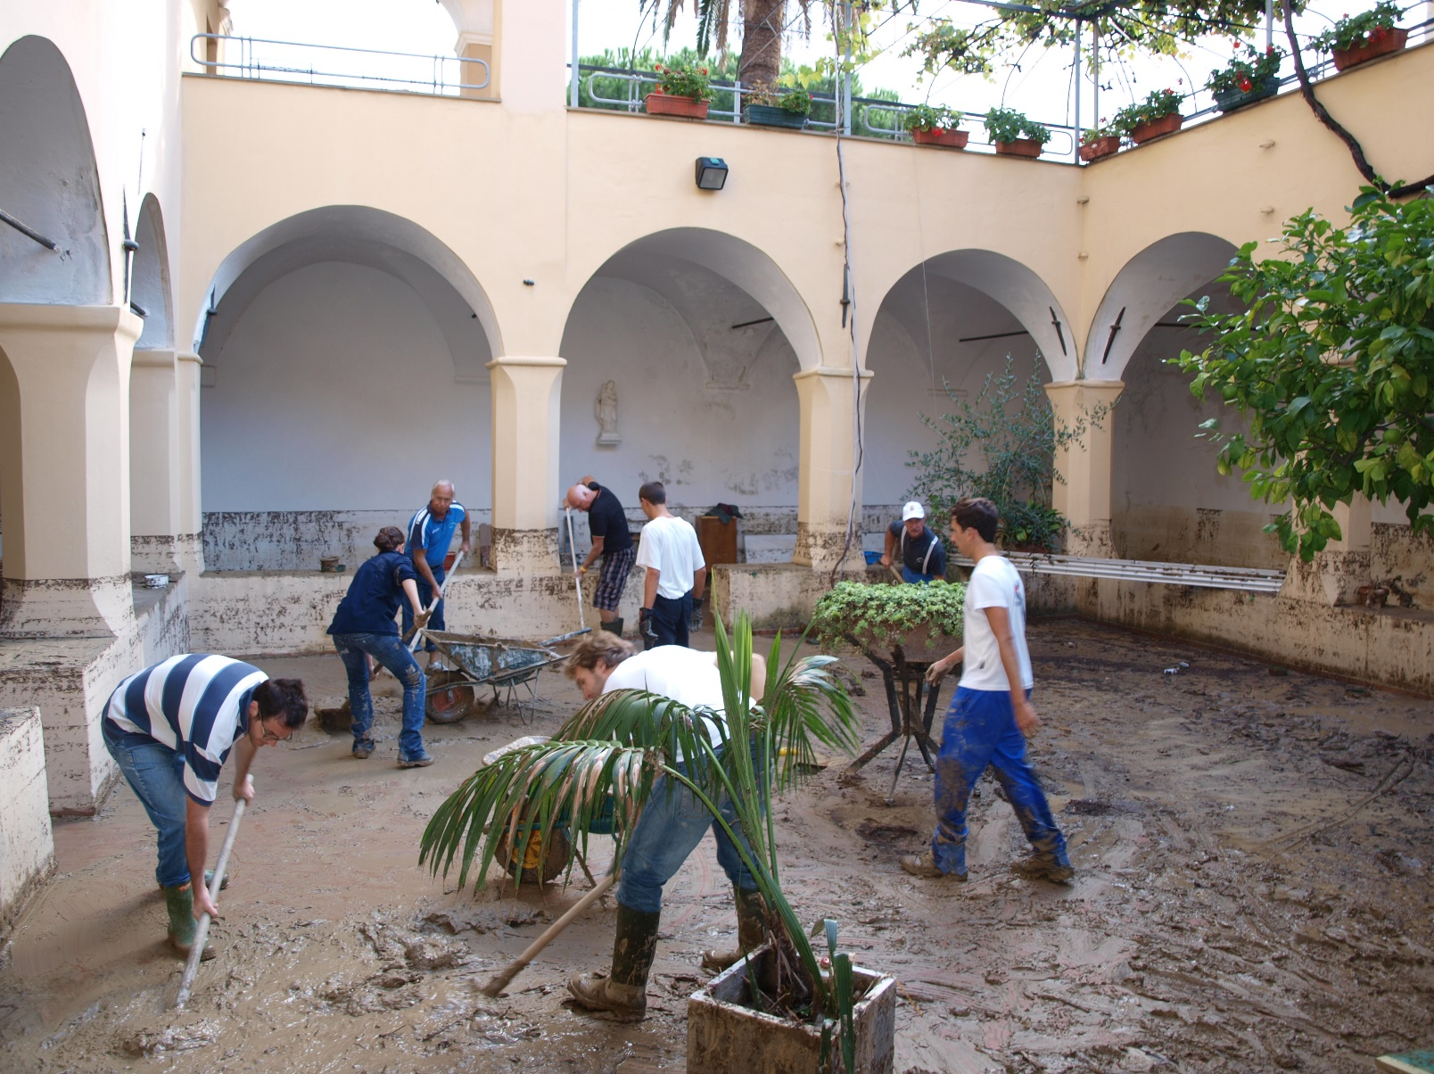

Unaffiliated spontaneous volunteers at Church of San Domenico, October 2010, Varazze, Italy. © Massimo Lanfranco.

STRUCTURE
Some spontaneous unaffiliated volunteers accept pre-existing organizational structures. This type of volunteer is known as a convergent volunteer: a person who converges to where officials need help and accepts direction on how to support the official response (Cone et al., 2003).
Other spontaneous unaffiliated volunteers may over time choose to form a new organizational structure or adapt existing structures to new crisis management purposes. These structures are of varying maturity and complexity and evolve over the course of a group’s lifetime. The more mature an organization becomes, the better their internal care and support structures are expected to be. For example, in the case study of VOST Portugal in the Cyclone Idai response below, there is a description about how the organization has already started to establish special care for its volunteers. More mature organizational structures also make it easier to establish contact with an informal group. Thus, emerging volunteer organizations can be given guidance and support to establish care for their members. Individual volunteers and loose groups of volunteers, on the other hand, are more difficult to approach and retain contact with. In these cases, providing a framework within a more established organization that offers care and support may be the better approach.
All types of volunteers can be placed within these four dimensions. Established crisis management organizations have the most experience and success with volunteers who have a high level of all four dimensions: fully affiliated with the organization, clearly embedded in its structure, over a significant period of time and at a stable and planned location. On the other end of this continuum are the bystanders who have no affiliation, act outside any type of structure, for a very short time in the location where they just happen to be at the moment of the incident.
The two examples above, clearly show that providing care and support to volunteers can be complicated and challenging. It is the aim of this working paper to shed light on some of the considerations that crisis management organizations must do in order to fulfil their duty of care.
In the section, ‘Designing policies that work for spontaneous unaffiliated volunteers’, we focus on the dimensions of affiliation and structure.
In the section, ‘Operational considerations for care and support of spontaneous unaffiliated volunteers,’ we focus on the dimension of location and time.
In the section, ‘Digital volunteers’, all four dimensions come together in an exploration of a new and growing type of volunteers that has not yet been sufficiently described and addressed in crisis management.

THE CHALLENGES AND BENEFITS OF CARING, SUPPORTING AND PROTECTING SPONTANEOUS UNAFFILIATED VOLUNTEERS
The nature of volunteering is changing; communities are engaging with social, humanitarian and development causes in new ways. People do not necessarily subscribe to the idea of life-long voluntary service for the same organization but rather see themselves as agents of change in relation to concrete causes and social movement. Spontaneous unaffiliated volunteers can offer their services to established crisis management organizations or self-organize in ad hoc groupings with no or little organizational support.
The lines between people affected by a crisis and the volunteers responding to a crisis are blurring. Volunteers are often members of the affected community, and thus are likely to be personally affected by the crisis to which they are responding to. In social work with vulnerable groups, people who belong – or have belonged – to the vulnerable group are often recruited as volunteers. This is sensible because as peers they have a deep understanding of the needs and culture of the affected people. But they may also themselves be more vulnerable (Thormar et al., 2012).
This affects the ways in which volunteers can and should be cared for; support systems should be flexible and able to address the needs of the more fluid groups of volunteers.
Volunteers, whether affiliated or unaffiliated, responding to a crisis are often in the first line of events. They work under physically and mentally difficult - sometimes dangerous - circumstances. During their involvement, volunteers regularly experience high levels of stress at work, which may cause an increase in sickness levels, risk-taking behaviour or security incidents because of impaired judgment. In contrast to unaffiliated volunteers, affiliated volunteers can be pre-registered, receive training and in certain situations be invited to join a crisis that they might have previous experience of. Furthermore, the deploying crisis management organizations have both an organizational and a moral duty to care for their staff and affiliated volunteers, especially when they work in high-risk situations that have the potential to lead to distress.
While the issue is in focus in most organizations working with volunteers, both in the humanitarian and European civil protection sector for affiliated volunteers; there is very little evidence in the literature to suggest that this is also the case for spontaneous unaffiliated volunteers. The following section presents a case with a focus on the pressures especially spontaneous unaffiliated volunteers are most likely to experience during their involvement in a disaster or crisis. It further investigates some overall challenges and benefits which occur as a result of working with spontaneous unaffiliated volunteers during a crisis.

CASE EXAMPLE: EMOTIONAL CHALLENGES FACED BY SPONTANEOUS UNAFFILIATED VOLUNTEERS PROTECTING A STUDENT CLUB FROM FLOODS
A case example from the floods in Dresden, Germany in 2013 shows the emotional challenges and pressures spontaneous unaffiliated volunteers faced there, who were trying to protect their student club from the floods (Deutches Rotes Kreuz, 2014).
- Some of the spontaneous unaffiliated volunteers reacted very emotionally and angrily towards what they called ‘flood-tourists’, i.e. people who just came to watch the water rising while they had been working for 24 hours or longer, to protect their club.
- Others were very disappointed by the communication and the support offered by the city’s authorities, who focused on the protection of e.g. historical buildings in the old part of town.
- A lack of appreciation of their work was felt as an affront by many of them.
- Other spontaneous unaffiliated volunteers in Dresden have been emotionally touched by the direct contact with people who have been directly affected by the floods (e.g. losing their property).
- Many spontaneous unaffiliated volunteers in Dresden felt mentally exhausted and overloaded during and after the response.
This example shows a variety of emotional distress issues that spontaneous unaffiliated volunteers can experience when risking their health and even lives, in trying to protect and help others. The impact of many of these stressors would be minimized by more information, training and experience that are protective in nature that is provided for affiliated volunteers as well as for staff of disaster risk reduction and response organizations. Spontaneous unaffiliated volunteers on the other hand are often unprotected due to lack of organizational support and are thus in need of extra support. Therefore, it is not only a moral duty to take care of those helping during disasters and emergencies, be they organized in established disaster response organizations or not. It is also in the interests of governments and their respective disaster response systems to include spontaneous unaffiliated volunteers not only in the existing response mechanisms, but also in the aftercare that is in place for affiliated volunteers. Since it is a global trend that less and less people are willing to voluntarily engage in humanitarian and emergency responding organizations, the integration of spontaneous unaffiliated volunteers becomes more and more important. This is of course not only true during an acute crisis, but also in its aftermath. In this regard, unaffiliated volunteers should have the same rights as those who are part of the established response system.
The following section will highlight some of the benefits and challenges when involving spontaneous unaffiliated volunteers.

BENEFITS OF INVOLVING SPONTANEOUS UNAFFILIATED VOLUNTEERS IN DISASTER RESPONSE
There are several good arguments for involving spontaneous unaffiliated volunteers during and after disasters; often spontaneous unaffiliated volunteers are locals from the affected or neighbouring communities. This implicates some helpful aspects for the response. People from the affected or nearby communities have knowledge and understanding of local needs and traditions and are usually trusted by the affected local population. They have insider knowledge, which responders from other parts of a country or even from abroad often lack. Therefore, they usually enjoy more credibility among the local population, as opposed to helpers that are flown in. Local people also know best about the infrastructure and existing resources, and often have the best ideas about how to access the most vulnerable population in their communities. While rescue teams from other locations and abroad first need to mobilize, coordinate and travel to remote areas, spontaneous unaffiliated volunteers are often the first ones on the scene and start with emergency measures without all the logistical obstacles that people from further away face. This time factor is especially important after earthquakes or during floods, when there is only a limited amount of time to rescue victims.
For people belonging to disaster-affected communities, being active in the response during crisis and emergencies, being included in the rebuilding of their environment can have a positive impact and this active involvement can support personal coping strategies. Research shows that a feeling of self-efficacy is an important factor in recovery after crises (Hobfoll et al., 2007). Volunteering to help in the community is empowering and not feeling completely dependent on help from others has a positive effect on people’s well-being. Being part of the response mechanism gives people the opportunity to move from being mere “beneficiaries” to being active members of their community. This can help to make survivors of disasters more resilient in future catastrophes.
As a result of being involved in disaster response, spontaneous unaffiliated volunteers from the affected community gain important skills, which they can use in case of other emergencies in the future. Including spontaneous unaffiliated volunteers from the affected community will therefore increase the disaster preparedness of societies, beyond the borders of existing response mechanisms.
But also, spontaneous unaffiliated volunteers from the outside may be of importance. They may bring with them special skills or knowledge that might be very useful for the affected population. Profits and risks faced by spontaneous unaffiliated volunteers may also be mitigated by motivation (Shaw et al. 2015).
The increasing pervasiveness of contemporary information and communication technology in crises and disasters first and foremost social media channels and platforms, means that information from within the disaster area is disseminated faster and with larger outreach than at any other point in the past. This creates an immense volume of data. Some of this data may be relevant and useful to crisis management organizations and NGOs but requires a lot of resources to process into usable information. Involving digital volunteers presents a specific subset of benefits. Digital volunteers can help with this task by collating and filtering data to provide concise reports that are useful for decision makers.
Currently, many organizations face the expectation that they must enter a two-way communication with the public: to provide information, answer questions or give guidance. Like the processing of data on social media, this form of engagement requires a large amount of resources, which are already stretched thin. Digital volunteer groups could take over the active communication with members of the public to alleviate the resource strain on other organizations. Involving digital volunteer organizations in direct communication with the public requires a high level of trust and clear guidelines for how and what to communicate.

CHALLENGES AND RISKS OF INVOLVING SPONTANEOUS UNAFFILIATED VOLUNTEERS IN DISASTER RESPONSE
The following extract highlighted several benefits for crisis management organizations to consider when working with spontaneous unaffiliated volunteers. This section will scrutinise some challenges and risks that crisis management actors must take seriously and take into account when working with spontaneous unaffiliated volunteers.

“So, we went out there to collect the wounded people and also the dead bodies. So, we went up to the scene. From there it was very hard for us, so me being the first time in the field. I was really weak while carrying out the activities because I could see dead bodies here and another person crying there, and – okay, to give service, now, I was feeling like I wanted to cry, so it was a challenge for me.” (Griffiths et al., 2018)
A particular risk factor for spontaneous unaffiliated volunteers is their inexperience. Some spontaneous unaffiliated volunteers are the first on the scene and therefore they often start helping without registration with any formal organization (Imperiale & Vanclay, 2019). Without registration, established crisis management organizations have very few ways of providing the necessary care and support. Even if an ‘unaffiliated volunteer center’ is later established to offer access to care and psychosocial support, many local volunteers may not make use of it. Yet, inexperienced volunteers who are first at the scene are actually in even greater need of support after an emergency, as findings show that they “scored more highly on intrusive thoughts, inability to control emotions, depression or anxiety scales than experienced workers” (Brooks et al., 2015).
Another risk factor is the degree of affectedness and involvement. Local people might get a more central role, as they possess local knowledge. (UNDRO, 1982) It has also been shown that it is often spontaneous unaffiliated volunteers with strong local networks who get deeper involved in the response or recovery work (Roine & Kvarnlöf: in review). Consequently, they potentially have a higher risk of being put into situations that can lead to distress and a further need for psychosocial support. This is often accompanied by loss of resources which volunteers from the affected community have experienced. To volunteer during a crisis and emergencies can have a negative impact on people and can challenge personal coping strategies. Local volunteers are often personally affected by the crisis and emotionally closer to the incident. They know the place and the people involved and may therefore experience greater difficulties and will require more support.
Having the option to help is more important for local than for non-local volunteers. There is the possibility of greater mental challenges manifesting for local people if they do not find ways to feel useful during an event. According to Thomar (Thormar et al., 2015), most spontaneous unaffiliated volunteers come from the disaster affected community.
However, the level of affectedness differs and can therefore be subdivided into three levels:
- Directly affected: these volunteers come from the community itself; some volunteers will
have lost family members or friends, considerable resources, their livelihoods and even their social networks.
- Indirectly affected: these volunteers may come from the affected community or also from
outside of it. They may have indirect ties to those affected e.g. by knowing someone close to
them who was affected.
- Non–affected: these volunteers come from outside of the community and have no ties to the
community at all and do not know any of the affected people.
An additional risk factor is the lack of training. Not being trained (neither to perform the job, nor on safety) puts spontaneous unaffiliated volunteers and others at risk, especially when overestimating their skills and abilities. Such risky behaviour, even if carried out with good intentions, causes additional work for trained experts, who are needed to help other victims of a disaster.
Besides training, spontaneous unaffiliated volunteers also often lack adequate equipment which is needed to work in emergency settings. Therefore, established organizations often have to equip spontaneous unaffiliated volunteers with e.gs. sandbags, pumps, shovels or protective gear.
Another risk stems from lack of coordination. Since they are not part of established relief organizations and their networks consist of other spontaneous unaffiliated volunteers, they often lack an efficient coordination mechanism. This opens up the risk of working outside/around established governmental structures or crisis management structures, which can result in inadequate prioritization or causing more harm than good. Spontaneous unaffiliated volunteers who disagree with the priorities of established crisis management organizations or who feel poorly cared for or unwelcomed by these organizations may self-organize to carry out emergency work in ways that are detrimental to the overall effort.
Finally, having no social network can be a risk too. Non-local volunteers might not have anyone from their personal network in the area and who would be able to understand what the unaffiliated volunteer is going through. Therefore, they might not get the same informal debriefing as local people, when talking over the event with friends and family.
This is especially true for digital volunteers, who are spatially distributed. Digital volunteers have a high risk participating in an ephemeral manner; they may participate in data gathering and filtering for a few days and then vanish (digitally speaking), leaving no way to contact them afterwards. However, they may still require care, as they may have come in contact with affected people and/or sensitive or disturbing media during their work.

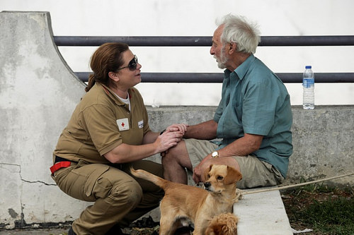
In 2017 forest fires saw 1,500 people forced to evacuate in Spain this weekend when blazes swept parts of Andalucia. In Portugal, hundreds of people now face the overwhelming challenge of coming to terms with what has happened and beginning to think about how to rebuild their lives. A total of 326 volunteers and staff, including 25 psychologists and five social workers from 39 branches are involved in supporting the worst-hit communities to recover. ©IFRC

DESIGNING POLICIES THAT WORK FOR SPONTANEOUS UNAFFILIATED VOLUNTEERS – OPPORTUNITIES AND RECOMMENDATIONS
People showing up at the scene of an emergency offering their help is not a new phenomenon. Communities have always come together to help each other out in times of crisis. But as crisis management has become increasingly organized, professionalized and regulated, less room has been left for spontaneous unaffiliated volunteers. In recent years, a shift has been seen in the way many people volunteer. They are less loyal to established organizations and more driven by causes and events. For crisis management organizations, this means that recruiting volunteers that are prepared to make a long-term commitment is more challenging; there are increased numbers of more spontaneous unaffiliated volunteers becoming involved during crises, by offering their services to the established organizations and by self-organizing in more or less coherent groupings.
The decision whether to work with spontaneous unaffiliated volunteers in crisis management or not rests upon a multitude of organizational, legal and practical factors and can only be made locally. The previous section has highlighted benefits and certain risks connected to working with unaffiliated volunteers. It further highlighted the various pressures especially experienced by spontaneous unaffiliated volunteers and the need to formalize how to work with spontaneous unaffiliated volunteers on both an organizational and governmental level.
This section aims at informing policy makers on different levels: local, national, regional and international, about the importance of spontaneous unaffiliated volunteers and their current situation. It highlights the importance of setting up support mechanisms that are readily available and accessible to spontaneous unaffiliated volunteers as emergency responders and presents key considerations and recommendations for action to be implemented.

CURRENT STATE OF PLAY: GLOBAL FRAMEWORKS FOR WORKING WITH VOLUNTEERS IN CRISIS
Global policy and practice are developing to promote the well-being of staff and volunteers. For example, UN Resolution 70/129, Integrating volunteering into peace and development: the plan of action for the next decade and beyond, recognizes the role that volunteers play in the implementation of the 2030 Sustainable Development Agenda (UN, 2015). As such, the resolution requests that Member States and the United Nations system work together with volunteer-based organizations to enhance the protection, security and well-being of volunteers.
Resolutions adopted by UN member states, signatory states to the Geneva Convention, the National Red Cross and Red Crescent Societies, call for the creation of an environment that protects, safeguards and cares for volunteers. These resolutions commit policy makers at all levels to take the necessary steps to better support people voluntarily stepping forward during crises and emergencies to care for others:
- The UN Resolution70/129, Integrating volunteering into peace and development: the plan of action for the next decade and beyond, requests Member States and the United Nations system “to work together with volunteer-involving organizations to support efforts to enhance the protection, security and well-being of volunteers, calls upon States to create and maintain, in law and in practice, a safe and enabling environment for volunteers, and encourages the adoption of good practices in the promotion, facilitation and, where applicable, management of volunteerism”. (UN, 2015)
- International Resolution 5 of the 32nd International Conference of the Red Cross and Red Crescent on the safety and security of humanitarian volunteers calls on States “to promote the safest environment feasible for humanitarian volunteers, bearing in mind the inherent risks in some of their activities, including, in accordance with national practice, measures to promote public understanding and acceptance of the role of humanitarian volunteers, the integration of measures to protect volunteer safety and security in national laws, policies, plans and programmes for emergency management, and measures to hold perpetrators of crimes against humanitarian volunteers accountable. The Resolution also encourages States […] to develop and/or maintain national systems for the collection and dissemination of comprehensive data, including sex and age disaggregated data, relevant to the safety and security of humanitarian volunteers in a manner consistent with applicable national law and calls for international data collection efforts on humanitarian safety to also include information about volunteers”. (IFRC conference, 2015)
- In December 2019, the 33rd International Conference of the Red Cross and Red Crescent on adopted the resolution Addressing mental health and psychosocial needs of people affected by armed conflicts, natural disasters and other emergencies which, encourages States “to work to strengthen the quality and capacity of the workforce (mental health, health and social welfare staff and community health workers, including trained volunteers) responding to the mental health and psychosocial needs of people affected by armed conflicts, natural disasters and other emergencies in close cooperation with the components of the Movement and calls upon States […] to take measures to protect and promote the mental health and psychosocial wellbeing of staff and volunteers who are responding to humanitarian needs across all sectors, equipping them with the necessary skills to cope with stressful situations and responding to their specific mental health and psychosocial needs”. (IFRC council of delegates, 2019)
This increasing recognition of the importance of ensuring the safety and well-being of volunteers on the global level, however, does not always mean that there are good support systems in place on the ground, even for affiliated volunteers. Barriers include limited understanding of the issue, lack of acknowledgement from management and organizational and structural barriers.
The next case illustrates how especially spontaneous unaffiliated volunteers were integrated into the crisis management structure.

CASE EXAMPLE OF GOOD INTEGRATION OF SPONTANEOUS UNAFFILIATED VOLUNTEERS IN EMERGENCY RESPONSE STRUCTURES: THE COMMONWEALTH OF AUSTRALIA’S POLICY ON SPONTANEOUS VOLUNTEERS
Learning from the experiences of several natural catastrophes in their country, e.g. Cyclone Larry (2006), the Queensland floods (2010), the Canberra bushfires (2003), and the Victorian bushfires in 2009, the Government of Australia recognized the importance of managing spontaneous unaffiliated volunteers. This includes the different levels of public administration, national, state or territory and municipal or local level, but also for volunteer and emergency management organizations. Therefore, the Department of Families, Housing, Community Services and Indigenous Affairs funded the development of the Resource Kit on Spontaneous Volunteer Management kit; (Commonwealth of Australia, 2010).
The resource kit is a guideline for managing spontaneous volunteers and includes recommendations on how state actors can support spontaneous volunteers in different stages of an emergency. It “is designed to fit into current state and territory arrangements and is flexible and able to be adapted to meet the needs of jurisdictions, municipalities and organizations” and therefore is a good example on how to improve care and support structures for spontaneous volunteers. (Commonwealth of Australia, 2010)
The resource kit contains examples on how to draft a framework, a communication strategy and an implementation plan:
- Framework: the draft framework aims to support community recovery by enabling an effective management of spontaneous volunteers. It is designed to fit into Australian State and territory arrangements and is flexible enough to be adapted to the needs of the jurisdiction, municipalities and emergency responding organizations. The framework contains a very helpful overview of which activities actors working on different levels (national, state or territory, municipal or local) can do in different phases of an emergency, in order to support an efficient involvement of spontaneous volunteers.
- Communication strategy: media (including social media) play a crucial role when it comes to the recruitment and management of spontaneous volunteers. Therefore, it is important how official authorities communicate during emergencies. The strategy of the Australian Government for example, includes key and generic messages that should be used by different actors during an emergency. In addition, it suggests using e.g. pre-education messages to encourage the public to pre-register as spontaneous volunteers, to embed the media messaging in the state or territory public information management system, and to send post-emergency messages and appreciations to spontaneous volunteers.
- Implementation plan: the document aims at helping official authorities and organizations to adapt the draft framework and draft communication strategy for their local needs. For example, it gives examples on possible roles national actors can play, provides advice on strategic and operational implementation of the framework and it suggests how spontaneous volunteers can be managed successfully. Regarding the management of spontaneous volunteers, several processes are suggested. For the post-deployment phase, it is for instance recommended that “the spontaneous volunteer is advised where they can seek help on occupational health and safety following the debrief, should they feel the need for further assistance.” (Commonwealth of Australia, 2010)
The resource kit is a useful document when it comes to the integration of and the support for spontaneous volunteers during emergencies. It is recommended that other states develop similar documents and ensure that the recommendations are widely disseminated and implemented on all levels and from all actors involved in a national response plan. For this purpose, in 2015 the Australian Government endorsed a national Spontaneous Volunteer Strategy: Coordination of volunteer effort in the immediate post disaster stage. (Australian Government, 2015) The strategy includes principles, policy considerations and suggested actions for managing spontaneous volunteers, which have been adapted from the 2010 resource kit.
In addition to the 2010 resource kit and the 2015 national strategy, the Australian Government also published a Disaster Resilience Handbook Collection, providing guidance on national principles and practices for disaster resilience. Another handbook was published in 2017, Communities Responding to Disasters: Planning for Spontaneous Volunteers. It helps communities to decide on a case by case level if the involvement of spontaneous unaffiliated volunteers makes sense and contains further and quite specific guidance for communities on how to involve spontaneous unaffiliated volunteers in disaster responses. (Australian Government, 2017)
Such a comprehensive and well thought out- approach concerning the involvement of spontaneous unaffiliated volunteers is desirable for all countries. Such detailed planning and preparedness on all levels of disaster response helps not only to guarantee an effective response mechanism, but also increases the likelihood that spontaneous unaffiliated volunteers will be successfully integrated in the crisis management system and will therefore experience fewer challenges during and after their deployment.

RECOMMENDATIONS FOR THE FUTURE
This section presents recommendations on ways to improve the structural support for spontaneous unaffiliated volunteers as well as topics to explore and develop further. The recommendations are based on research findings, experiences from the field and best practices from around the world. The bibliography at the end lists useful articles and tools for policy makers, crisis managers and organizations working with spontaneous unaffiliated volunteers.

- Strengthen and update legislation related to care and support to volunteers.
- Volunteering legislation or other legislation such as disaster laws need to be updated, especially to support the rights and responsibilities of spontaneous unaffiliated volunteers, including the right to access psychosocial support and other forms of care.

- Build and strengthen organizational structures and international standards and collaboration efforts to support spontaneous unaffiliated volunteers
- Several organizations have standards in place for working with volunteers in crisis management. These standards must be robustly tested and improved in as many contexts as possible in view of having a list of minimum standards that apply to all volunteers, including spontaneous unaffiliated volunteers and the particular requirements and needs of this group.
- States should exchange on an international level their experiences working with volunteers, in order to learn from each other and to improve the management of not only affiliated volunteers but also spontaneous unaffiliated volunteers and support mechanisms across borders. Armed conflicts, natural disaster and other emergencies often have cross-border impacts and therefore, international standards are needed.
- Reports about natural and man-made disasters easily reach a big audience via internet, TV and social media. This increases the number of people who get emotionally affected and who want to help. Therefore, emergency response planning and management should from the very beginning include a national strategy on how to involve and manage spontaneous unaffiliated volunteers that move from unaffected to affected areas. Experiences from past catastrophes can help design such inclusive emergency preparedness plans (for an example for successful management of spontaneous unaffiliated volunteers see Paciarotti et al., 2018).
- Ensure that mental health and psychosocial support for all affected persons as well as for all staff and volunteers including spontaneous unaffiliated volunteers is an integral part of emergency response plans at the national level.

- Invest to prevent and respond to the mental health and psychosocial needs of populations
- Investments need to be made in local and community-based actions to prevent and respond to psychosocial needs of the population as well as those of the helpers. These investments can be directed to trusted local organizations or groups working on the area of health at the community level.
- Invest in local structures (can be health facilities or organizations) to better support spontaneous unaffiliated volunteers who may need MHPSS or similar. Local authorities and formal local volunteer involving organizations should be supported by national authorities to set up those structures where spontaneous unaffiliated volunteers can go to if they need support.
- Invest to strengthen the capacity and quality of health care workers responding to psychosocial needs at all levels.

- Extend the research on topics related to care and support for spontaneous unaffiliated volunteers
Only within the past few years have questions arisen relating to the involvement of spontaneous unaffiliated volunteers in humanitarian and emergency relief that have gained more and more attention by researchers from different backgrounds. Therefore, many topics have not yet been sufficiently explored.
- Importantly, the psychological consequences for spontaneous unaffiliated volunteers, and how to meet their needs best during and after their involvement deserves serious attention. It is therefore recommended for state authorities and universities to invest in the exploration of the phenomenon, in order to have valid research findings to build support structures on.
- Another relevant topic for future research is the effective management of spontaneous unaffiliated volunteers by crisis managers or formally recognized volunteer involving organizations.
- Furthermore, it would be helpful to conduct research on barriers to care for spontaneous unaffiliated volunteers. What prevents them accessing care after the disaster and how can these barriers be overcome?
- Finally, while quite some research exists on the effects of volunteering on individuals in general, it would be very helpful to explore if these positive effects are also true for spontaneous unaffiliated volunteers, or in the alternative, it would also be useful to examine if, due to their non-affiliated status, that they are rather more at risk of facing negative effects. (Thormar et al., 2015) The loss of not properly capturing their experiences in research is also an issue of concern. Related to this, more research is also needed to investigate under which circumstances spontaneous unaffiliated volunteers can safely be included as resources in crisis management and when they should be treated as affected people in need of mental health services. This in turn impacts how mental health care plans and models are drawn up. Here further research is also needed.

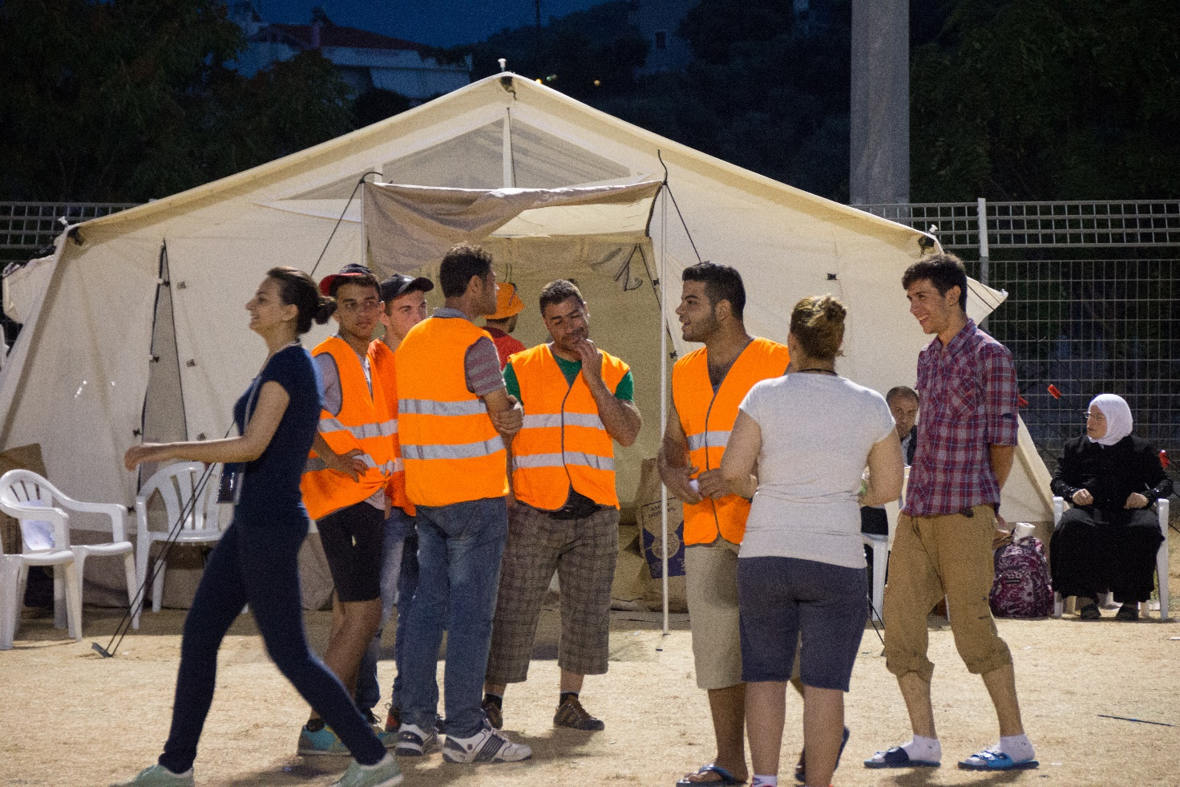
A group of around 20 young Syrian migrants has been volunteering side by side with the volunteers from the NGOs, including Hellenic Red Cross volunteers. ©Thomas Andre Syvertsen/ Norwegian Red Cross

OPERATIONAL CONSIDERATIONS FOR CARE AND SUPPORT OF SPONTANEOUS UNAFFILIATED VOLUNTEERS
This section will discuss how to care for spontaneous unaffiliated volunteers in the field and discuss what kind of practical planning, actions and decisions needed before, during and after an event to address the challenges and reap the benefits presented above.

DIFFERENT NEEDS FOR CARE AND SUPPORT FOR LOCAL AND NON-LOCAL VOLUNTEERS
In the field, spontaneous unaffiliated volunteers can be divided into two overall groups: local and non-local. In any kind and dimension of event or disaster, someone will survive and take care of those in need, thereby becoming spontaneous unaffiliated volunteers. The local volunteers are the people also affected by the event or disaster. Their main motivation in helping may be to protect their own family, neighbours, property or community.
The non-local volunteers come from outside the area and their main motivation may be to help other people or the excitement of being present and helping during an emergency. When it comes to organizing care and psychosocial support, those two groups might have different needs.
Often the local volunteers are the ones in most need of care and support because they are also personally affected by the crisis. Their worries and concerns related to relief work is not only connected to themselves, but also to their own homes and/or communities. However, it is important not to overlook the non-local volunteers. They can be people deliberately travelling to the disaster area motivated by a desire to help, but they can also be people being there by coincidence and are drawn into the relief work. This is especially the case for events coming without warning, such as terror attacks or sudden onset natural disasters. In this instance, tourists often become spontaneous volunteers.
The deliberate and coincidental non-local volunteer will leave the area after the event. If they have not been registered as spontaneous unaffiliated volunteers by a crisis management organization, they may never receive any offer of support after the event and are left to organize their own mental health and psychosocial support.
Local volunteers are surrounded by people with the same experiences as themselves. Being part of a group of people who all had the same experience may be helpful if the group is able to support each other in beneficial ways. Maybe the volunteers from the affected group have the chance to be part of a structured and safe formal or informal debriefing together with other survivors. This will not be the case for the non-locals. Maybe they have difficulties finding social contexts in which to talk about their experiences in a structured and safe way. In this case, non-local volunteers can be compared to digital volunteers, with some of the same concerns and attention requirements. See the chapter on digital volunteers below for further recommendations.

CASES
When it comes to identifying who needs care and psychosocial support after being a spontaneous unaffiliated volunteer, is it not possible to rule anyone out (DEFRA, 2015). Therefore, the following cases present different very situations illustrating the need to include these services in all crisis management planning.

FLOOD RESPONSE IN JYLLINGE, DENMARK
In December 2013, a storm surge hit the small coastal town of Jyllinge in Denmark. It was first time this area experienced a flooding event, where 268 houses were flooded, and people were evacuated. Local people tried to help, mostly consisting of people whose own houses were endangered. The situation was chaotic and took both the professional emergency management and the local homeowners completely by surprise. Over the course of the following year the damaged houses were refurbished or rebuilt. In January 2015, a second storm surge threatened the same area. This time not only the locals whose houses were under threat, but also many other people turned up to help. In 2016, 2017 and 2019 the town was again hit by either small or large storm surges. Each time, cooperation between the professional emergency management and the spontaneous unaffiliated volunteers was improved. By late 2019, some of the local people had received training to be better prepared to help in future flooding events. After the last flood in January 2019, a representative of the local spontaneous unaffiliated volunteers was invited to be a part of the group of professionals coordinating the response.
This shows a process whereby the spontaneous unaffiliated volunteers have become integrated into a still more well-organized part of the flood emergency management. The reasons for this are mostly practical, as the professional emergency management organization do not have the resources for the necessary preparedness and response work without help from the volunteers. However, there also exists an awareness of the psychosocial aspects of this.
"When people are under pressure, simply being able to take part, whether it is holding a door, carrying a sandbag or pouring a cup of coffee means that you have taken part, and this means that afterwards, when you speak with your neighbours, you might get a little better feeling that ‘I did what I could"(Nielsen, 2019)
During the first flood in 2013, everybody was taken by surprise, and no structure existed for either psychosocial support or care for the affiliated or unaffiliated volunteers. This however improved during the following flood events. Now the spontaneous unaffiliated volunteers are registered (as much as possible) and the local Red Cross organization has also offered care and support.

LESSONS
- Local people's frustration or feeling of being helpless are reduced when involved in meaningful volunteer work: either in the front line (moving sandbags or putting up movable barriers) or in support work (providing food, transport etc.).
- The non-affected volunteers become affected by contact with affected people. They often need help to work through those experiences.

TERROR INCIDENT IN TEL-AVIV, ISRAEL
A few days after a terror incident took place in Tel Aviv, Israel, in 1994, that caused 22 fatalities and injured several dozens of people, a woman came to donate blood in one of Magen David Adom’s ambulance stations. During the preparations for the donation process, she started to cry. When approached by a senior first aider who was on duty that day, she explained that she lives near the terror incident location and that she went out to provide first aid when she heard the explosion. She treated a few casualties, not all of whom survived. Since then she had become very sad, having difficulties sleeping and she kept wondering if she could have treated the survivors better. At the ambulance station, when she heard sirens again and saw the ambulances and the crews, all the emotions and memories of that day came back to her.
The first-aider asked her about the things she saw and did, and after a few minutes, he told her that from his perspective it sounded like she did the best she could. The injuries she described were fatal, she had no medical equipment and training, and even if an ambulance had been as there from the first minute, the casualties would probably have died anyway, regardless of the level of care they might have received. The woman thanked him and left.
In this case, the first-aider provided support and used his professional medical background to convince the woman that she did the best she could. Since he was a first-aider by profession and had a lot of experience, his support was credible, and the woman heard what she needed to hear. If the first-aider was also trained in providing psychosocial support, he would have been able to reassure her that her feelings and reactions were perfectly normal reactions following a highly distressing situation and were indicative of what could be expected in the near future and how she could get additional support. On the other hand, if she had been supported only by a psychosocial professional, she wouldn’t have been able to receive feedback about the first-aid that she provided and would probably remain with doubts.
After an accident, a sudden disaster or armed attack the bystanders present at the scene are the first responders. They call for help and provide first aid to the injured until the professional responders arrive.
Bystanders who provide first aid in emergencies and disasters are a specifically vulnerable group, as they are very close to the incident location, and it normally takes a while for the formal responders to arrive. Thus, the bystanders are exposed to difficult situations, including seeing many casualties with severe injuries. Very rarely will a bystander have the experience, training or medical equipment to treat very severe injuries. Casualties with fatal injuries die in front of them and the bystanders might feel helpless. Often, the bystander will be providing assistance to someone they know: a relative, a neighbour, or a friend. This situation will raise questions after the incidents, like: "what could I do differently?", "was I able to help more?", "did I do the right things?"
An after-action session conducted by a psychologist with no medical background might not be sufficient for the bystander that wants to be reassured that he or she did the right thing and best they could have for the casualties. This is something that requires a strong pre-hospital background (needed also for the credibility of the person providing the feedback). In the same manner, a pre-hospital care provider may not have the necessary psychosocial support background and training that will allow her/him to understand the psychosocial needs behind "technical questions"; as a result, provides only a "good technical answer" that does not meet the needs of the person asking. For that reason, it is of great importance to create a response methodology that will care for the needs of this specific group, involving first aid or pre-hospital care and understanding of the psychosocial needs of the person.

LESSONS
- First aiders should have basic psychological first aid skills in order to be able to better support spontaneous unaffiliated volunteers during and after events.
- When being approached by spontaneous unaffiliated volunteers that expresses distress, the person being approached should register the person and offer further support.
- Comments, advice and feedback given by experienced field personnel can be meaningful and should be delivered in a proper and a professional way.

RECOMMENDATIONS
The overall recommendation is the need for including care and psychosocial support in all plans related to spontaneous unaffiliated volunteers in the field.
Organizations involving or cooperating with spontaneous unaffiliated volunteers need to discuss how broadly they see their responsibility. To what extent is the care and psychosocial support for spontaneous unaffiliated volunteers something to include in the decision-making processes during a response? Is the organization responsible for the mental well-being of local people volunteering after an event? Can and should the organization accept offers of help from spontaneous unaffiliated volunteers? Several questions must be confronted depending on the type of organization committed to working with spontaneous unaffiliated volunteers (in general, public bodies have a precise “duty of care” towards all citizens).
In those discussions, the following dilemmas and questions should be considered:

- Are the spontaneous unaffiliated volunteers local or non-local, and do those two groups need different types of care?
- Often there is a gap between the types of tasks spontaneous unaffiliated volunteers expect to perform and the type of tasks they are asked to perform. Matching and managing expectations is important to ensure further collaboration and increase community resilience. An onboarding process for unaffiliated volunteers that take mismatched expectations into account must be considered.
- Professional organizations are often very careful about maintaining a good reputation, so the spontaneous unaffiliated volunteers might be requested to go through core training before being allowed to help, e.g. an introduction to the core principles of the organization. This can be frustrating for the spontaneous unaffiliated volunteers who are often very eager to start the work. When managing spontaneous unaffiliated volunteers throughout the cycle of operation, there is a risk of mistrust occurring as organizations don't know for how long the spontaneous volunteers will work with them; they just allocate basic tasks for them, resulting in the volunteer failing to gain an interest in repeating the experience.
- Separating the spontaneous unaffiliated volunteers from the affiliated volunteers can create a feeling of not belonging or of being perceived as less important. A balance between not putting the spontaneous unaffiliated volunteers in danger and making them feel important, therefore has to be aimed for.
- For spontaneous unaffiliated volunteers who have provided first-aid in mass casualty situations, the providers of psychosocial support should have knowledge about psychosocial support, psychological first aid as well as physical first aid. Alternatively, first aiders should be offered psychosocial support as well as a debriefing with a medical professional.
To begin the implementation of these recommendations, it may be helpful for organizations to analyse how they engage with unaffiliated volunteers. This analysis can be supported by the analyses of different types of volunteers in the chapter Ways to describe and understand spontaneous unaffiliated volunteers.

OVERALL RECOMMENDATIONS FOR SUPPORTING SPONTANEOUS UNAFFILIATED VOLUNTEERS BEFORE, DURING AND AFTER EVENTS
As spontaneous unaffiliated volunteers are exposed to sometimes very challenging and stressful experiences, support structures are needed in different stages of their involvement. To avoid negative psychological consequences, at least brief instructions preparing them for their work are needed. During their involvement in the response, there should be forms of mentoring and supervision in place, e.g. peer meetings at the end of each shift, and a counsellor available for those who need to talk bilaterally. Since many spontaneous unaffiliated volunteers only realize after a certain time how much they are burdened with what they experienced, post-placement counselling and support structures should be available (Griffiths et al., 2018).

Before | During | After
Set a response system that will cater to the needs of spontaneous unaffiliated volunteers, involving first aid or pre-hospital care and psychosocial knowledge and experts.  Plan two-way communication systems with spontaneous volunteers. Often the best solution is to use the channels already in use as Facebook groups of local communities, housing cooperations, the local scout or Red Cross organization.  Train potential team leaders in the response organizations in psychological first aid (PFA) so they will be able to support spontaneous unaffiliated volunteers in the future. Train team leaders in psychosocial self-care so they will able to take care of themselves while supporting the spontaneous unaffiliated volunteers. | Ensure the collection of contact data from spontaneous volunteers.  Focus on clear communication structures, to give the volunteer the experience of knowing what is going on and being able to help in the best way.  Support the front-line volunteers (e.g. with food, shelter and so on), as they could feel they are a part of the solution and improve their sense of belonging of a common effort to overcome the emergency.  Make sure that spontaneous unaffiliated volunteers receive feedback on questions and comments. | Always make an effort to actively seek out local volunteers who might not have been registered.  Ensure follow-up meetings for all spontaneous volunteers involved in the operation, both for providing emotional support and for a technical debriefing.  Apply evaluation and perform surveys to assess the behaviour and expectations of organizations, spontaneous unaffiliated volunteers and persons affected by the crisis.  Remember to provide communication to the public regarding the employment of spontaneous unaffiliated volunteers.

LEARNING FROM PUBLISHED GUIDELINES
A number of guidelines about spontaneous unaffiliated volunteer management have been published. The key materials are summarized here to serve as a point of departure for those wishing to develop guidelines tailored to their own organizations. In the guidelines, care and psychosocial support are mentioned to different extents. The table below gives an overview of recommendations concerning care and psychosocial support from the following guidelines:
- Points of Light (2004) Managing Spontaneous Volunteers in Times of Disaster: The Synergy of Structure and Good Intentions. Points of Light Foundation & Volunteer Center National Network. https://www.fema.gov/pdf/donations/ManagingSpontaneousVolunteers.pdf
- Volunteer Florida (2005) Unaffiliated Volunteer Management: Florida’s Record-breaking 2004 Hurricane Season. Governor’s Commission on Volunteerism & Community Service. https://www.volunteerflorida.org/wp-content/uploads/2013/03/UVM_2004season.pdf
- DEFRA (2015) Spontaneous volunteers: Involving citizens in the response and recovery to flood emergencies. Department for Environment, Food and Rural Affairs Flood Risk Management Division. Final report FD2666. http://randd.defra.gov.uk/Document.aspx?Document=13013_FD2666_FinalReport_SpontaneousVolunteers.pdf
- Australian Disaster Resilience (2017) Communities Responding to Disasters: Planning for Spontaneous Volunteers. Australian Disaster Resilience Handbook 12. https://knowledge.aidr.org.au/media/5618/aidr-communities-responding-to-disasters-planning-for-spontaneous-volunteers-handbook.pdf
- ISO 22319:2017(en) Security and resilience — Community resilience — Guidelines for planning the involvement of spontaneous volunteers. https://www.iso.org/obp/ui#iso:std:iso:22319:ed-1:v1:en
- Key actions for care and support for unaffiliated volunteers at organisaitonal and field levels
For a more detailed presentation of the recommendations in the key guidelines, please see the section Overview of guidelines, immediately below.
In the tables, the following abbreviations apply:
- SUV: spontaneous unaffiliated volunteers
- PSS: psychosocial support
- PFA: psychological first aid

 | Organizational-structural-managerial level | Individual - direct operational level
Before | Discuss what the primary goals and motivation are to have SUV involvement: e.g. to get extra hands, build community resilience and/or to provide psychosocial support to affected communities.  Train potential team leaders in the response organizations in psychological first aid (PFA) so they will be able to support the SUVs in the future.  Train team leaders in psychosocial self-care so they will able to take care of themselves while supporting the SUVs.  Develop and implement a risk assessment of the tasks the SUV will carry out.  Decide what support to offer SUVs in form of care and PSS during and after their involvement.  Make plans for the implementation of training team leaders and managers in PSS.  Develop cooperation with local mental health professionals to provide pre-disaster training for volunteer centre staff and to assist at the centres during disaster response.  Consider how to support SUVs to be sensitive to protecting themselves from the effects of trauma.  Identify principles of communication to SUVs: whether, how, when, and what to communication to SUVs before, during and after  Develop public media strategies about SUVs aimed at the general public including information about risks, where to go and what to bring. | Clear designation of responsibility for on-site coordination of SUVs.  Create procedures for declining offers of help from SUVs if the risk is too high or due to their lack of suitability. Aim is to maximize positive outcomes and to reduce the risk of compounding negative outcome.  Implement a process to determine an SUV’s skills, interests, and ability to do the assigned work and geographic area preference.  Identify ways to reduce frustrations of SUVs waiting to be assigned to a task.  Build a volunteer reception or centre ‘go kit’ which includes office supplies, processes, tools, and forms.  Implement processes to monitor the safety and wellbeing of SUVs during and after the volunteering period.  Plan two-way communication system with SUVs. Often the best solution is to use the channels already available, such as Facebook groups of local communities, housing cooperations, the local scout or red cross organization.
During | Coordination of a clear communication to make sure the SUVs know reasons for orders or tasks.  Establish a volunteer reception centre where SUVs are referred.  Set a response system that will cater to the needs of SUVs, involving first aid or pre-hospital care and psychosocial knowledge and experts. | Match an SUV’s capabilities with the demands of the tasks.  Provide information on available medical and mental health services to ensure the well-being of all workers.  Ensure the collection of contact data from SUVs.  Focus on clear communication structures, to give the SUV the experience of knowing what going on and being able to help in the best way.  Support the front-line SUVs (e.g. with food, shelter and so on), as they could feel they are a part of the solution and improve their sense of belonging to a common effort to overcome the emergency.  Ensure feed-back to an SUV’s remarks.  Continually recognize the efforts of individual SUVs and the community.  Continually monitor SUV motivation to avoid or to be prepared for an SUV’s departure before the incident is over.  Appoint suitably experienced people to in charge of effective briefing and debriefing.
After | Develop methods to evaluate an SUV’s’ experience — both the process and outcome. | Provide personal contact with each SUV after they have completed their service.  Reward and recognize an SUV’s efforts i.e. thank them as part of debriefing and think of options for additional recognition and rewards.  Provide PSS services during the recovery process including: counselling, operational debriefing, or mental health screening.  Always make an effort to actively seek out local volunteers who might not have been registered.  Ensure debriefing or follow-up meetings for all SUVs involved.  Use evaluation and performance surveys to assess organizations, SUV and victim’s behaviour and expectations.  Remember to provide communication to the public regard the SUV employment.

DIGITAL VOLUNTEERS
Digital volunteers may become instrumental in dealing with the large amount of data that is generated by information and communication technology in crises and disasters, particularly on social media. Before this can happen, challenges about their participation need to be addressed. This section highlights how digital volunteers can contribute to disaster response and what the obstacles to this contribution currently are.
In disastrous situations, a sheer volume of data comes through at high speed which requires to be analysed in order to respond effectively and allocate resources where mostly needed. Digital volunteers are increasingly becoming part of the disaster response and recovery operations and have become critical for official organizations faced with managing large-scale disastrous events to assist in data collection and sense-making. This is happening despite many issues and challenges emerging from the involvement of these digital actors remaining unresolved. This section is set to unveil and briefly dig into some of these issues. Currently, many of these issues are addressed on a case by case basis and are based on the good will of the actors involved. However, as the phenomenon of digital volunteers is predicted to grow in the next few years, it becomes imperative to explore and address these issues in a more systematic fashion. We will firstly try to frame the phenomenon of digital volunteerism and provide the reader with a definition of a ‘digital volunteer’ in order to set the boundaries of the role. Then we will highlight some key issues and recommendations for policy.
The efforts of civil society to respond to extreme events can manifest in different forms of volunteerism; volunteers may work alone at the disaster site or they may support an existing organizational structure, or even form ad hoc groups. Volunteers may already be affiliated with an emergency organization, or they may have no ties at all to any formal organization. They may have professional training in areas relevant to crisis and disaster management or come completely unprepared. As diverse as the forms of volunteering are, so are their varied definitions (Auferbauer et al.,2019). The present section is dedicated to a specific form of volunteering; the work of digital volunteers, who operate through information and communication technology (ICT) to support emergency organizations by gathering data and processing information.

ABOUT THE DIGITAL VOLUNTEER
To demarcate the subject area of this paper, we define a digital volunteer as follows:
“A digital volunteer is an unaffiliated or affiliated volunteer who is not physically located in the incident area and who uses information and communication technology to collate data and compile information, possibly in a collaborative effort with other digital volunteers”.
Digital volunteers are distinguished by several factors: their location, the time of their participation, their affiliation with established emergency organizations, and the degree of structure they exhibit in their organization as well as the type of activity they conduct. By these dimensions, digital volunteers can be classified as follows:

DISTINGUISHING CHARACTERISTICS OF DIGITAL VOLUNTEERS
Location | Outside the area affected by the disaster.
Time | Potentially active during all phases of crisis and disaster management.
Affiliation | Not gainfully employed with formal crisis management organization.
Structure | May be active as individual volunteer or within a pre-structured group.
Activity | Data gathering, information processing, information distribution.
Table 2 Distinguishing Characteristics of Digital Volunteers
For the purposes of this paper, we surmise that digital volunteers are active outside the affected area. This assumption goes hand in hand with the type of activity we attribute to them: gathering data from diverse digital sources, processing data to transform it into information, collating information and distributing this information to consumers for whom it is relevant; as opposed to volunteers within the affected area, who participate in the relief efforts more directly (e.g. through physical support or by contributing data from the incident site). This activity is conducted not as part of gainful employment within the emergency response system. Notably, this definition leaves open the possibility of emergency organizations expanding their own organizational structure with volunteers to provide surge capacity for dealing with information overload. Digital volunteers may work alone or as part of a collaborative effort – though tendentially they will join communities of similar interests (Hughes & Tapia, 2015). These communities will have organizational structures in place to support the collaborative work, to varying degrees. Nevertheless, a single person can be active as a digital volunteer, e.g. to distribute information by relaying verified information to their social circle. Digital volunteers use diverse means of communication for information-gathering: in a crowdsourcing effort with other digital volunteers and under a structure that is informal, but that may resemble that of an official emergency organization.
It is perhaps, expedient to discuss the demarcation of digital volunteers by virtue of their physical location – especially because it deviates from other popular definitions of ‘digital volunteers’ and ‘digital volunteerism’ (Büscher et al., 2014; Whittaker et al., 2015). Physical location during an extreme event results in different behavioural patterns on social media. Those ‘outside’, who are not directly affected by the event engage in commentary-related communication and collective sense-making (Stieglitz et al., 2018). Volunteers within the affected areas are more likely to be consumers of information, as well as producers of data; they seek information to facilitate their own decision-making (Simon et al., 2015). Furthermore, the aftermath of crises and disasters may leave the communications infrastructure in the affected area crippled or disabled altogether (Jennex, 2012), making it difficult for digital volunteers (per the above definition in this paper) to provide their services. Thus, delimiting digital volunteers by their location is, in and by itself, not coherent; as being present at the incident site does not prohibit digital volunteerism. Rather, this distinction is a logical conclusion of our premise about their activity and motivation; that digital volunteers do not provide data themselves and that they are producers, rather than consumers, of collated information. On-site volunteers who use ICT to consume information, contribute data or organize collaborative efforts in situ are, in our opinion, better described by the term ‘digitally enabled volunteers’ or ‘digitally enabled emergent volunteers’ (Waldman & Kaminska, 2015).

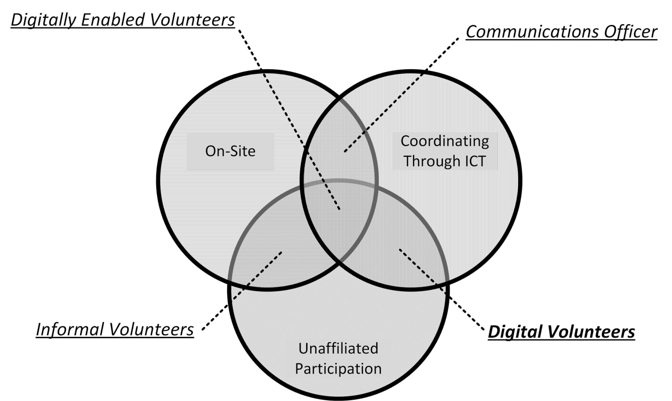
Figure 1 Differentiating Between Informal, Digital and Digitally Enabled Volunteers
A digital volunteer operates and performs different tasks in the three different stages of any catastrophic event, be it natural or man-made, namely:
- Before: Amplifying official information to the populations and monitoring social networks, as well as playing a pedagogical role
- During: Gathering information, validating information and relaying that same information to authorities and populations alike
- After: Keeping the information flowing, identifying needs, validating information and relaying information

INFORMATION SEEKING, SENSE-MAKING AND TECHNOLOGY
The need for information-seeking and rumour in crises and disasters has been purported since the early days of disaster research: "Heightened interest in and lessened means of ascertaining distant events make for many rumor stories" (LaPiere, 1938). Anxiety about the situation leads to the generation of rumours (Bordia & DiFonzo, 2002). Rumours are not necessarily detrimental in crises and disasters. Rather, they represent a pooling of resources as part of collective information-seeking behaviour (Aguirre & Tierney, 2001; Bordia & DiFonzo, 2002; Oh et al., 2013). Contrary to what one might expect, the advance of ICT has neither lessened the propagation of rumours in the absence of certain information nor reduced the difficulties that one faces in information-seeking. The data generated e.g. on social media can be helpful for increasing social awareness, but at the same time the volume of data exceeds what is humanly possible to process (Hiltz & Plotnick, 2013; Mukkamala & Beck, 2017; Simon et al., 2015). ICT has led to new information-seeking practices (Shklovski et al., 2008). Technological platforms have facilitated the composition of inter-related interpretations about the current situation (referred to as ‘intersubjective sense-making” (Stieglitz et al., 2018). ICT is being used to peer-produce accurate information through collective intelligence (Palen et al., 2009). In their quest to collate and synthesize information, digital volunteers will form groups online to conduct specialized activities or provide services (Hughes & Tapia, 2015). For this, they appropriate existing ICT infrastructure – first and foremost social media and collaborative online platforms – and incorporate digital tools into their organizational structure (Starbird, 2012; Voida et al., 2015). The assortment of various general purpose tools forms a heterogeneous network of people and platforms, making up a diverse digital ecosystem (Cobb et al., 2014; Dailey & Starbird, 2017). Despite being not specifically designed for this purpose, social media, which makes up a sizeable amount of this ecosystem in the form of appropriated infrastructure, is considered to be a good fit for this type of work. (Voida et al., 2015; Dailey & Starbird; Waldman & Kaminska, 2015)

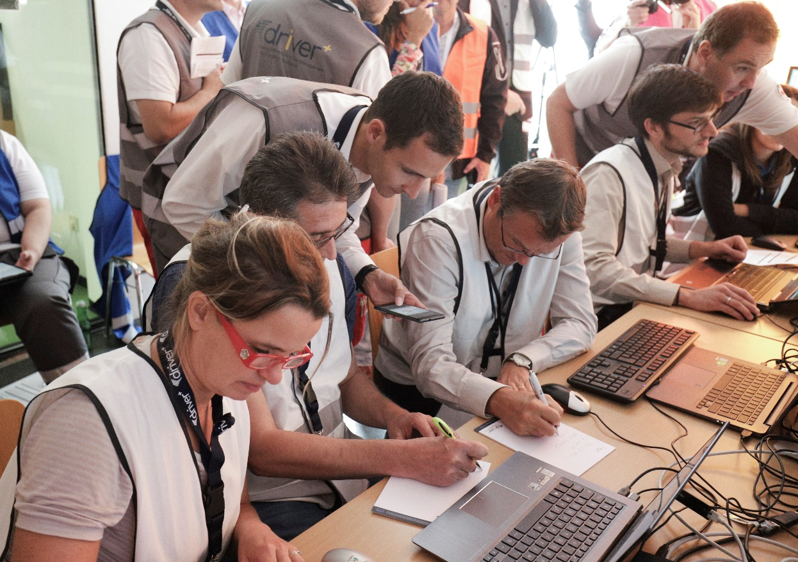
Trial Austria 2019 ©Driver+

BENEFITS OF USING DIGITAL VOLUNTEERS IN CRISES
The high volume of data on social media, as well as its variable quality and relevance, makes social media a problematic source of information (Simon et al., 2015). This is true both for citizens seeking information for their own decision making and for emergency organizations trying to piece together a complete operational picture of the situation. Literature that discusses information seeking behaviour often refers to an information dearth (Haworth et al., 2018; Majchrzak & More, 2011; Oh et al., 2013; Palen et al., 2009; Shklovski et al., 2008). Information dearth means an “absence of timely information needed for personal decision-making and peace of mind”. Ironically, as opposed to an information dearth, there is also commonly an information overload in times of crises and disasters. Information overload means that there is too much information being broadcasted in crisis and disaster situations that it is not feasible for humans to locate relevant updates (Hiltz & Plotnick, 2013). Information dearth and information overload can occur at the same time, when a high volume of data flows through social media, but only a small part of it is trusted or useful. To overcome information dearth and information overload, lay people can self-organize as digital volunteer communities for information processing and communication facilitation (Kaufhold & Reuter, 2016; Starbird & Palen, 2011). Digital communities and moderators collate and amplify relevant information through a synthesis of structured dissemination (Kaufhold & Reuter, 2016). Digital volunteers perform fact-checking and source identification; in contrast to the rumour-mongering that is usually associated with public involvement (Palen et al., 2009). Through this, digital volunteers can play an important role in overcoming information dearth and overload, by providing relevant information to the public without overwhelming them (Majchrzak & More, 2011).
Through their continued work, digital volunteer communities formalize continuous work practices that endure over multiple incidents, and establish permanent organizational structures (Cobb et al., 2014); reorganizing themselves into stable networks (Hughes & Tapia, 2015). Communities that perform this transition to established digital organizations can become trusted agents in the eyes of emergency organizations. Trusted digital volunteer organizations have the potential to enhance the information processing and communication capabilities of emergency organizations (St. Denis et al., 2012). However, emergency organizations not only face the issue of having to process a large volume of data for their own operational picture. They are also expected to shift towards a two-way communication with the public, which necessitates rapid assessment and verification of information (Simon et al., 2015). Emergency organizations need to balance the pressure of communication through social media against a lack of standardized procedures for doing so, against the additional strain of accepting the public accountability this brings, and against the responsibility they accept when engaging in two-way communication (Hughes et al., 2014). Digital volunteers may play an important role in alleviating the tension of this situation for emergency organizations. Structured, trusted and digital volunteer communities with training relevant to communication with the public and affected persons could take over active communication with the public if they were to receive adequate support from governmental agencies (Roth & Prior, 2019).
Digital Volunteers: Examples and Cases
There are several examples of mature digital volunteer organizations. The Standby Task Force (emerged from an ad hoc initiative of collaboratively mapping important resources and events online, during the Haiti earthquake of 2010 (Liu, 2014; Whittaker et al., 2015). The Standby Task Force supports on-the-ground response by providing surge capacity to process online data (Liu, 2014). They have developed a community through ongoing social relations facilitated by online communication tools. Formalization and organizational maturity has developed within the Standby Task Force in the form of activation protocols and division of labour in task-based teams (Liu, 2014). The Standby Task Force was activated ‘officially’ by UN-OCHA in 2012 to collect information, identify pictures, categorize them, and compile situation reports from that information (Liu, 2014; Meier, 2012). Humanity Road is another digital volunteer organization that emerged from efforts to provide information during disaster situations (Starbird, 2012; Whittaker et al., 2015). Humanity Road provides monitoring, filtering and verification of social media data, as well as synthesis of new digital artefacts to support the affected population as well as responders (Starbird, 2012; Starbird & Palen, 2013). Humanity Road formalized in the sense of division of labour and incorporation as non-profit organization (Starbird & Palen, 2013). Humanity Road and the Standby Task Force have deployed together to provide crisis maps in several disaster events (Starbird, 2012), indicating a network of networks that spans digital volunteer communities.
The inception of a Virtual Operations Support Team (VOST) conceptualises the integration of trusted agents into an emergency response, whereby said agents establish and monitor social media communications (St. Denis et al., 2012). A VOST can be mobilized to “extend communication capacities and provide operational support” to emergency organizations (St. Denis et al., 2012). A VOST may be integrated quite extensively with established emergency organizations to become a trusted party. The VOST concept has been adapted to specific geographical and social contexts around the world, in response to immediate needs of online communication (Roth & Prior, 2019). Virtual Operations Support Teams these days are a mix between digital volunteers and digitally enabled volunteers, with a strong focus on having the most reliable information as fast as it is available.

CASES

VOST PORTUGAL (CYCLONE IDAI RESPONSE 2019, MOZAMBIQUE)
On 14 March 2019 the category 2 cyclone Idai made landfall causing catastrophic damage in Mozambique, Malawi and Zimbabwe.
A request for special activation was sent to VOST Portugal by VOST Europe before the cyclone made landfall. VOST Portugal’s engagement was more pronounced due to language and historical ties between Mozambique and Portugal. VOST Portugal was tasked by VOST Europe to counter the amount of rumours, which started occurring as well as the lack of reliable official information that is needed for citizens and crisis managers to make informed decisions. VOST Portugal, using a network of contacts, managed to open communication channels with local authorities, as well as at state level, with NGOs on the ground, and a group of Portuguese citizens that lived in Beira. These channels, and the information exchanged in them, became VOST Portugal’s source of information.
From that moment VOST volunteers gathered, validated, adapted and shared information in its social networks. At the same time connections were made with the official entities of Mozambique, national and international aid organizations that were already in Mozambique or planning to make an intervention there.
Volunteers were exposed to a large amount of data, including images and videos, some of which were turned out to be fake. Large catastrophes tend to produce lots of fake information and typically as “blood sells”, news outlets are more concerned about publishing headlines they can easily sell rather than ensuring that the information published is valid. VOST’s overall managerial responsibility was to ensure that the digital volunteers remained focused while sorting all data and monitor their behaviour in the face of false information.
Given the nature of this intervention, special attention was paid to the digital volunteers’ well-being and to protect them against the harmful effects of exposure to violent images and textual content shared from Mozambique. Whilst the main task was to continue to provide validated information to assist the population and provide official entities, a dedicated digital communications room was created to provide various means of psychosocial support to the digital volunteers spanning one-on-one chats, group chats at the end of each shift, and specialized help made available at any point of time for the volunteers. Volunteers received structured support to enhance their emotional well-being.
VOST Portugal’s intervention during the cyclone Idai was atypical; working with little or no information and lack of contacts on the ground, the first task was to identify possible stakeholders that could be considered as reliable sources of information. This task was set as high priority and involved all the volunteers. One group was dedicated to find reliable information channels, to build a contact database and to monitor several social networks. Another group skilled in programming languages developed a system that local people in Mozambique could use to enter information about missing loved ones. The list with missing people was then shared with Portuguese and Mozambican authorities and NGOs on the ground, via the contact list created by the volunteer group involved in building a contact database.
The list of people collated by the digital volunteers was shared with the Portuguese Secretary of State who left for Mozambique with the details. VOST Portugal’s volunteers were able to locate 30 people by using a network of contacts, geolocalization of pictures, and even the reservation system of a hotel chain. With the help of information gathered by VOST Portugal’s volunteers, a spontaneous group of people in Mozambique was able to identify more than 120 people that were safe. VOST Portugal’s volunteers were also responsible for bridging the gap between those on the ground and those abroad; informing them that their loved ones were safe.

About VOST Portugal
VOST Portugal’s interventions are guided by the group of founders, based on information that is gathered daily by volunteers. Every day there is a core team that monitors social networks, traditional media and other media outlets to take the pulse of what is worrying populations in terms of emergencies and public safety, as well as data gathered from civil protection (wildfires, inundations, major traffic accidents) and meteorological services, that allows for a clear picture of whether an intervention is needed or not.

LESSONS
Digital volunteers often experience intense exposure to potentially distressing imagery and information.
Digital volunteers often conduct their work from their own homes, physically removed from other volunteers and team members.
Careful planning of the working hours and types of tasks combined with structured support during and after interventions are essential to ensure the emotional well-being of digital volunteers. Depending on the nature of the intervention and the geographic location of the volunteers this support can be digital or in-person or a combination of the two.

VOST PORTUGAL FUEL CRISIS APRIL/AUGUST 2019
VOST Portugal is one of the most technologically prepared VOSTs; a core group of 15 developers can be expanded with a base of additional volunteers during an intervention. The core group develops codes to meet the needs of each intervention.
In April and August 2019 Portugal experienced a crisis of fuel shortage. VOST Portugal designed a platform where people could find information about the current availability of fuel in any given area.
During the last fuel crisis, which lasted for 12 days in August 2019, the volunteers worked from the early morning till late night. It took a toll on everyone involved. Hundreds of emails needed to be answered and media inquiries needed addressing, with lots of volunteers needing to be managed in order to make sure their efforts would contribute to the overall intervention and their energy would not be misplaced. Apart from the operational concerns, mostly due to working with a platform that was being fed by crowdsourced data, the criticism regarding the validity of data had to be addressed one-on-one with volunteers that had spent more than three weeks programming the platform. Full transparency and continuous monitoring of volunteer well-being were the primary tools used to ensure that everyone was focused and on track. As a result of this activation, the team became even more solid; volunteers developed new skills, new features were added to the platform and a new batch of volunteers joined the organization. At an external level, the Civil Protection National Commander commended their work for helping not only the populations, but also the authorities to have an idea of the impact of the fuel crisis in the country, showing the importance that technologically oriented digital volunteers can have in the whole chain.

LESSONS
Digital volunteers are no less immune to being affected by public criticism of their intense efforts to mitigate a crisis. Because digital volunteers work off-site and, in the background, it’s easy to overlook this stressor. Organizations working with digital volunteers must monitor the well-being of volunteers and respond appropriately.
Due to the “behind the scenes” nature of digital volunteering, deploying organization should take additional care to ensure that they are amply acknowledged and on par with any other type volunteer.

HUMANITY ROAD RESPONSE TO AMATRICE EARTHQUAKE (CENTRAL ITALY, 2016)
When, on August 24 2016, an earthquake struck Amatrice in Central Italy, many digital volunteers were still on holiday. Being a digital volunteer can be boiled down to this; you never know when your help is required nor when you will get “virtually” deployed. Given that most of the news was in Italian, all the Italian volunteers were called to cooperate for data collection and to support news translation. The call for an intervention occurs usually via a direct email to all the volunteers asking for their availability to help, even for an hour or two. Coordinators are used to keeping responses operational, despite a high degree of turnover of volunteers (because each volunteer works based on his/her availability). The response of the volunteers was rapid, but particular volunteers were required to harvest information from multiple sources, such as local newspapers, Twitter feeds or national news agencies. Each piece of information was then posted in Skype windows used by the Humanity Road volunteers to coordinate their activities and tasks. In this way, everyone was aware of the information already collected and was able to highlight any discrepancies in the information found. At the end of each day, volunteer coordinators summed up all the information into a situational report that was then shared with the major international relief agencies and published on the Humanity Road website. The intervention lasted for few days and was concluded as soon as it became clear that the situation was stabilizing, and the operations were transiting into the early recovery phase.

LESSONS
Lesson 1: It may be difficult to convene volunteers online especially in holiday periods. A spreadsheet with the holiday rota can potentially resolve the issue.
Lesson 2: It may be difficult to figure out when the assistance of digital volunteers is no longer needed, and the activation period is over. Organizations working with digital volunteers must include exit strategies and appropriate follow-up on emotional well-being in the response planning.

CHALLENGES AND OPEN ISSUES CONCERNING DIGITAL VOLUNTEERS
Digital volunteers are increasingly being part of the disaster response and recovery operations and have become critical for official organizations faced with managing large-scale disastrous events to assist in data collection and sense-making. This is happening even though many issues and challenges emerging from the involvement of these digital actors remain unresolved. This section identifies and explores pertinent challenges and issues. Currently, many of these issues are addressed on a case by case basis and based to the good will of the actors involved. However, as the phenomenon of digital volunteers is predicted to grow over the next few years, it becomes imperative to explore and address these issues in a more systematic fashion.

LACK OF PHYSICAL PROXIMITY
Based on the definition given in this paper, digital volunteers work on their tasks in collaboration with others, but remotely (as opposed to spontaneous unaffiliated volunteers that operate on the ground during responses to disasters). Lack of physical proximity brings with it several issues, including difficulties to build a sense of trust and community, as well as legal implications concerning the identification of online volunteers. Indeed, the way in which a person presents oneself in the digital world may not reflect his/her offline identity. Lack of physical proximity makes it difficult for organizations to provide the training and support (including psychological support) that volunteers may need in the execution of the assigned tasks. This is especially true for volunteers who are not part of an organization or are part of an organization that has no prior experience in crisis and disaster situations. In these cases, volunteers may participate in data gathering and sharing tasks for a few days and then quit the tasks almost suddenly, leaving behind no information about them and giving no possibility to reach them out to check on their wellbeing.

ENGAGEMENT
Finally, the engagement and retention of digital volunteers represents a critical challenge for volunteer group coordinators and founders. In general, these groups experience an incredibly fast turnover, where members leave the group for a variety of reasons and are replaced very rapidly with new members. In some cases, the participation of volunteers to the group’s activity is on and off with people joining, then quitting and then re-joining after a while. While the participation of volunteers during times of activation is driven by a sense of urgency and the desire to help, it becomes more difficult to retain people’s engagement during downtimes.

TRUST
Trust is integral to the work of digital volunteers in many ways. First, digital volunteers have to trust each other as well as their coordinator, in order to collaborate and cooperate to achieve their objective; namely the finalization of a disaster-related task. Be it classifying remote sensing imageries or finding out the needs of a remote area stricken by an earthquake, the tasks that a digital volunteer must fulfil, require collaboration between several people. In most of the cases, digital volunteers do not know each other, and they come together in the same (virtual) location only to perform the task. As opposed to spontaneous volunteers who operate on the ground, digital volunteers cannot even benefit from the physical proximity that supports the feeling of “sharing the same experience in the same place”. This makes it difficult to conduct team building activity and create a sense of mutual trust between members of the same group. This difficulty is further exacerbated by circumstance such as an online persona not necessarily reflecting the natural person behind it, as was previously mentioned. Whilst founders and coordinators of digital volunteer groups try to compensate this issue by engaging members through drills, simulations and competitions during times of non-activation, the creation of a sense of being part of a group appears to be a challenge for digital volunteers.
Trust can also be considered in terms of credibility. Digital volunteers can and should question to what extent the information they retrieve online is credible or trustworthy. For this reason, some organizations such as VOST in Portugal have designed regulations and procedures for the verification of the disaster-related information. To begin with, only official information is considered reliable. Crowdsourced information is also considered but it must be checked with official entities. Secondly, the information is not posted directly by the digital volunteers; only the founders and veteran team members have access to the social media accounts.
Finally, digital volunteer groups can themselves be questioned for not being credible or trustworthy. In many cases, digital volunteers are not official organizations, in the sense of having a steering committee, internal regulations and a physical headquarter. On the contrary, they may have a loose internal structure and an evolving set of tasks and objectives to achieve. For this reason, some international relief organizations have long been wary of integrating the information collected by these groups in their decision-making process.

LACK OF SUPPORT
Another important issue that should be mentioned is the lack of support, in terms of appropriate training. In some organizations, short training is indeed offered to help volunteers gain some basic skills, such as self-organizing, collecting information, triangulating information and so forth. However, the fact that volunteers work each in his/her own spare time and that these times do not often coincide, makes it difficult for a group’s coordinator to organize a set of systematic trainings. This results in digital volunteers learning on the job or by example (i.e. looking at what others do).
While coordinators strive to support the work of digital volunteers during times of activation, little attention is given to what happens when the activation is over. Digital volunteers can be exposed to extremely stressful situations (e.g. watching pictures of dead people for days), which are likely to have long-term effects on their wellbeing and, in some extreme cases, on their coping capacities. Psychosocial support and ensuring the mental health of digital volunteers in the long run should be considered a priority if we are to involve these actors in the disaster response and recovery operations from the outset.

DISCONNECTION
Linked to the issue of lack of physical proximity is that of disconnection. Digital volunteers often work in a disconnected way, being only vaguely aware of what other organizations and groups of volunteers are doing in cyberspace. There is no commonly accepted way of indicating that a volunteer or group of volunteers is active for a certain incident; apart from using tagging or clustering tools that are particular to individual social network sites (e.g. hashtags). One group can be coordinating via Skype while another is active on Facebook. These groups work toward the same objective in a parallel fashion, but they never meet or converge. Contemporary social media networks and messaging services do not provide appropriate tools to support cross-network information exchange or coordination. Often, there is no central point on which groups or individuals can converge digitally, to exchange information about their activity or the situation in general. This increases the chance of duplication and waste of efforts. This disconnect between groups is not a phenomenon that is restricted to digital volunteers alone; however, lack of physical convergence points and meetings makes it more pronounced for this demographic.
Disconnect between the digital representations of volunteer organizations is partially technological in nature, but also has important organizational aspects. As many volunteer organizations are built on the spare time of their members, the core activity of the group often leaves little capacity for other tasks. Maintaining an active exchange with other groups or organizations is a resource-intensive endeavour and may simply exceed the capacity of smaller, informal groups. The disconnection issue has several implications on the ability to furnish digital volunteers with the support they need. Because they are ‘scattered’ in the cyberspace and their presence is continuously on/off. it becomes incredibly hard to take care of them, including the provision of psychosocial support. Established, more mature organizations can take the lead in providing and facilitating coordination by offering a framework to smaller groups or individuals.

A WAY FORWARD: RECOMMENDATIONS FOR POLICY ON DIGITAL VOLUNTEERS
Many questions about digital volunteers and their coordinators remain unanswered. Academics, practitioners and policy makers are called upon to address issues with regards to caring for digital volunteers, which are qualitative in nature and require an open debate and reflection on mutual practices. This working paper has tried to cast light on some of these issues and challenges, which may arise when trying to involve digital volunteers in disaster prevention and management operations. Some of these challenges relate to the very nature of the digital volunteer – how it can be defined and legally identified – others revolve around the management of information, tasks and group dynamics. We advise that research and policy will need to address the following issues:

RECOMMENDATION 1: Find ways to coherently identify a person with their online persona, while keeping in mind aspects of privacy and personal freedom.

RECOMMENDATION 2: Find ways to share and propagate information safely and legally. In particular, the sharing and protection of sensitive information is a matter that requires attention.

RECCOMMENDATION 3: Policies and practices should facilitate the creation of a sense of mutual trust in digital volunteers to counter the negative effects of the lack of physical proximity.

RECOMMENDATION 4: Provide training on information verification and validation for digital volunteers. Also, we must understand how to capitalize on the best practices that have emerged in existing organizations.

RECOMMENDATION 5: Parameters and benchmarks for how a digital volunteer group can be considered credible and trustworthy need to be developed and established.

RECOMMENDATION 6: Retention issues need to be systematically addressed through specific policies and practices to secure the engagement of digital volunteers, including during non-activation times.

RECOMMENDATION 7: Tools and instruments to allow digital volunteers to cooperate across different online platforms need to be devised.

RECOMENDATION 8: Psychosocial support of digital volunteers need to be performed as a long-term task rather than a one-off intervention. Policies related to digital volunteers should explain how the support will continue to be provided beyond the activation time.

RECOMMENDATION 9: Training needs should not be underestimated and the acquisition of the knowledge necessary to perform the required tasks and to take protective measures needs to be addressed thoroughly.

RECOMMENDATION 10: There is a need to explain how the work of digital volunteers is assessed and against which criteria.

TOOLS TO AID IMPLEMENTATION OF CARE AND SUPPORT MEASURES FOR SPONTANEOUS UNAFFILIATED VOLUNTEERS
In this section we include a small number of resources to aid implementation of organisational care and support measures for spontaneous unaffiliated volunteers. The resources reflect the emergent nature of this field and it is the hope of the authors of this working paper that the resources will be adapted, elaborated and improved by the reader. We also acknowledge that the resources form just a first step in this work, and we encourage everyone working with care and support to spontaneous unaffiliated volunteers to develop and share the next generation resources needed.

CHECKLIST FOR CARE AND SUPPORT FOR SPONTANEOUS UNAFFILIATED VOLUNTEERS
This short checklist contains key actions to ensure care and support for spontaneous unaffiliated volunteers

Before
- Set up a response system that will cater to the needs of spontaneous unaffiliated volunteers, involving first aid/pre-hospital care and psychosocial knowledge and experts.
- Plan a two-way communication system with spontaneous unaffiliated volunteers. Often the best solution is to use the channels already available such as Facebook groups of local communities, housing cooperation, the local scout or Red Cross organization.
- Train potential team leaders in the response organizations in psychological first aid (PFA) so they will be able to support spontaneous unaffiliated volunteers in the future. Train team leaders in psychosocial self-care so they will able to take care of themselves while supporting the spontaneous unaffiliated volunteers.
During
- Ensure the collection of contact data from spontaneous unaffiliated volunteers.
- Focus on clear communication structures, to give the volunteer the experience of knowing what is going on and being able to help in the best way.
- Support the front-line volunteers (e.g. with food, shelter and so on), as they could feel they are a part of the solution and improve their sense of belonging of a common effort to overcome the emergency.
- Ensure that there is a complaint mechanism in place and that spontaneous unaffiliated volunteers receive feedback for any comments and complaints they make.
After
- Always make an effort to actively seek out local volunteers who might not have been registered.
- Ensure debriefing or follow-up meetings for all spontaneous unaffiliated volunteers involved.
- Use evaluation and perform surveys to assess the behaviour and expectations of organizations, spontaneous unaffiliated volunteers and affected populations.
- Remember to provide communication to the public regard the spontaneous unaffiliated volunteer’s employment.

GUIDE: DEVELOPING ORGANIZATIONAL CAPACITY FOR CARE AND SUPPORT FOR SPONTANEOUS UNAFFILIATED VOLUNTEERS
Most crisis management organization encounter and engage with spontaneous unaffiliated volunteers in the course of their work. This guide intends to support organizations towards ensuring that these encounters and engagements include the appropriate level of care and support. The guide supports organizations to develop sound and deliberate understanding, thinking and approaches to care and support for spontaneous unaffiliated volunteers. It also supports organizations to determine what level of engagement is possible and appropriate.
The questions presented here include the most important questions that that organizations should consider when working with the care and support for spontaneous unaffiliated volunteers. The process needed to answer the questions is not outlined, as this is highly dependent on the individual organization. The questions are structured according to how spontaneous unaffiliated volunteers are defined in this working paper and it’s recommended that the questions are read and answered in conjunction with the detailed description of how spontaneous unaffiliated volunteers can be understood, as found in the questions immediately below.
Once the questions have been considered and answered, the bulk of the work in setting up the systems and structures for the care and support for spontaneous unaffiliated volunteers begins. As the relevant actions depend on the organization, the sites it operates in and many other factors that this guide does not cover. It falls to each organization to identify the action plan that follow.

INITIAL QUESTIONS TO MAP THE EXPECTED ENCOUNTERS WITH SPONTANEOUS UNAFFILIATED VOLUNTEERS:
- In which situations do we expect to encounter spontaneous unaffiliated volunteers (regardless of whether we want to or not)?
- What is the nature of our engagement with spontaneous unaffiliated volunteers?
      - Why – what kind of tasks do we hope they will/can carry out?
      - How – what conditions need to be in place for them to be able to carry out the tasks?

QUESTIONS TO BUILD A FRAMEWORK FOR CARE AND SUPPORT FOR SPONTANEOUS UNAFFILIATED VOLUNTEERS:
The following questions are structured according to the four dimensions used to understand spontaneous unaffiliated volunteers and guides you to consider and identify what is needed for your organization to provide quality care and support for spontaneous unaffiliated volunteers.

LOCATION
- Who do we anticipate the spontaneous unaffiliated volunteers that we will encounter/engage with will be?
- What are the implications for care and support?
TIME
- When in the crisis management cycle do we anticipate that spontaneous unaffiliated volunteers will be active?
- What immediate and long-term care and support do we need to provide?
AFFILIATION
- What is the expected level of affiliation?
- Will the people showing up have been registered beforehand (pre-registered volunteers)?
- Are they first-time volunteers?
- Do we want to or have to affiliate them to our organization to provide care and support?
- What should the affiliation look like?
- What do we do with the people that do not want to be affiliated (not engage, provide alternative support, other)?
STRUCTURE
- What kind of official structures are already in place for affiliated volunteers’ care and support?
- How do these structures connect to the structures for employees and affiliated volunteers?
- Are the spontaneous unaffiliated volunteers covered by insurance?
- Are the spontaneous unaffiliated volunteers allowed or urged to use the support and care systems for affiliated volunteers?

A SENSITIZATION WORKSHOP. HOW DO WE CARE FOR OUR SPONTANEOUS VOLUNTEERS?
The first step in implementing initiatives for supporting and caring for spontaneous unaffiliated volunteers is to make the decision makers aware of the need. To this end, a short and engaging workshop has been developed in DRIVER+ and CMINE. The workshop is aimed at anyone who might meet spontaneous unaffiliated volunteers from a managerial perspective. The workshop lasts one hour and is suitable for 12 to 24 participants.
The workshop is described in a visual playbook, which can be found here: http://pscentre.org/wp-content/uploads/2019/11/CMINE-sensitization-ws-playbook.pdf.
To carry out the workshop, the facilitator needs to make folded paper fortune tellers. Pre-made fortune tellers with folding instructions can be found here: http://pscentre.org/wp-content/uploads/2019/11/CMINE-senistization-ws-fortune-tellers.ppt

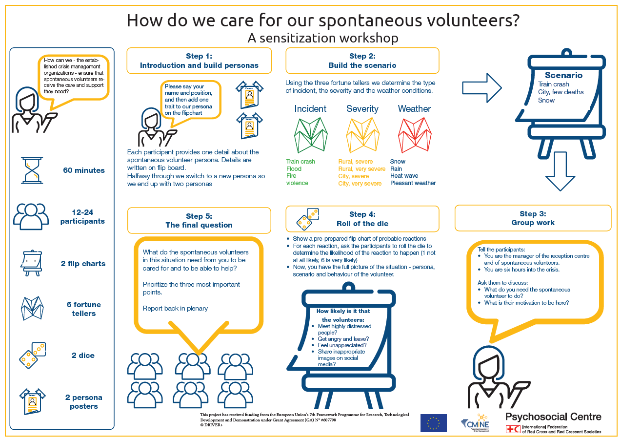

THE PSYCHOLOGICAL FIRST AID AND PSYCHOSOCIAL SUPPORT IN COMPLEX EMERGENCIES (PFA-CE) PROJECT
The Psychological First Aid and Psychosocial Support in Complex Emergencies (PFA-CE) project is a timely and important initiative as it responds to recent global developments which feature more frequent and long-term disasters and crises. The project aims at improving disaster response capacities of European emergency and volunteer organizations by considering needs and strengthening competencies in psychological first aid psychosocial support of staff and volunteers.
The project has developed a comprehensive set of training materials, which includes resources about working with spontaneous unaffiliated volunteers in complex emergencies: http://pfa-ce.eu/train.html

GUIDELINES FOR SUPPORTING STAFF AND VOLUNTEERS IN CRISIS
A tool for crisis managers and team leaders outlining resources and methods to support staff and volunteers during and after crisis. The guidelines were developed by the IFRC Reference Centre for Psychosocial Support in 2019. Can be downloaded here: http://pscentre.org/guidelines-for-supporting-volunteers-2

WHAT IS MENTAL HEALTH AND PSYCHOSOCIAL SUPPORT?
“Mental health” is defined by the World Health Organization (WHO) as a state of wellbeing in which every individual realizes his or her own potential, can cope with the normal stresses of life, can work productively and fruitfully and is able to contribute to her or his community. “Health”, according to WHO, is “a state of complete physical, mental and social wellbeing and not merely the absence of disease or infirmity”.
“Psychosocial” describes the interconnection between the individual (i.e. a person’s “psyche” including internal, emotional and thought processes, feelings and reactions) and their environment, interpersonal relationships, community and/or culture (i.e. their social context).
Psychosocial support addresses the dynamic relationships existing between the psychological and social effects of crisis, and between individuals, families, and communities. Psychosocial support is a process of facilitating resilience within individuals and communities, enabling them to move beyond the impact of crises and to deal with such events in the future in a positive way. By respecting the independence, dignity and coping mechanisms of individuals and communities, psychosocial support promotes the restoration of social cohesion and infrastructure. This means that both individual and community empowerment is at the heart of psychosocial interventions.
“Mental health and psychosocial support” is a term that serves to unite as broad a group of actors as possible and underscores the need for diverse, complementary approaches in providing a holistic continuum of care.

Hobfoll’s principles of psychosocial support in emergencies
In 2007, a group of experts came to a consensus on five intervention principles to guide practice in relation to crisis events. These principles have become known as ‘the Hobfoll principles’ and state that psychosocial intervention must focus on:
- ensuring safety
- promoting calm
- promoting self- and collective efficacy
- promoting connectedness
- promoting hope.

There is widespread consensus and support for the five intervention principles in psychosocial support in emergencies proposed by Hobfoll et al.
It is helpful to keep all five principles in mind. This ensures that the policy and practice include a range of different activities with different focuses. The principles are all inter-related. Promoting calming, for instance, is not possible if people do not feel some sense of safety, and without a feeling of connectedness, promoting collective efficacy is not easy. At the same time, not all activities can cover all five principles. Doing yoga exercises, for instance, is good for promoting calming, but does not necessarily promote connectedness. Facilitators also need to bear in mind the specific situation they are working in. For instance, in a safe and non-threatening environment, promoting a sense of safety may not be the main concern. (Hobfoll et al., 2007)

OVERVIEW OF GUIDELINES INCLUDEING MANAGEMENT OF SPONTANEOUS UNAFFILIATED VOLUNTEERS

UNAFFILIATED VOLUNTEER MANAGEMENT: VOLUNTEER FLORIDA
Volunteer Florida (2005) Unaffiliated Volunteer Management: Florida’s Record-breaking 2004 Hurricane Season. Governor’s Commission on Volunteerism & Community Service. https://www.volunteerflorida.org/wp-content/uploads/2013/03/UVM_2004season.pdf
This a report from Volunteer Florida looking at how organizations prepared and responded to the relief effort by spontaneous unaffiliated volunteers. They also used a survey to identify strengths, challenges, and impacts of spontaneous unaffiliated volunteers and all the elements that relate to the efficacy of the spontaneous unaffiliated volunteers and management of them. Based on the survey results and wrote the report and added a few bullet point recommendations for managing spontaneous unaffiliated volunteers.
Note in this report they call spontaneous unaffiliated volunteers, unaffiliated volunteers.
Time point | Organizational-structural-managerial level | Individual- direct operational level | Expectations of volunteers
Before | Roles and expectations of volunteer reception centre directors should be delineated | Documentation of where and when the volunteers were referred | Conduct an interview to determine the volunteers’ skills and abilities
Before | Volunteer centres should have further clarification for aspects of plans that deal with training on safety and risk management issues, as well as mental health issues for staff and volunteers
Before | Volunteer centres should develop MOUs with local mental health professionals to provide pre-disaster training for volunteer reception centre staff and to assist at the centres during disaster response
During | Coordination of a clear message being delivered by hotline call centres: message includes details about local conditions, so volunteers understand why they are being asked to go where they are going and for clear coordination between volunteer reception centres and hotline centres

FEMA GUIDELINES
Guidelines and Standards for Flood Risk Analysis and Mapping (FEMA). Points of Light (2004): Managing Spontaneous Volunteers in Times of Disaster: THE SYNERGY OF STRUCTURE AND GOOD INTENTIONS. Points of Light Foundation & Volunteer Center National Networkhttps://www.fema.gov/pdf/donations/ManagingSpontaneousVolunteers.pdf

This publication is offered as a basis for developing a national strategy on working with unaffiliated volunteers and is based on an analysis of effective practices and models. It is an outgrowth of an earlier publication, Preventing a Disaster Within the Disaster: The Effective Use and Management of Unaffiliated Volunteers, which outlined the challenges involved in working with unaffiliated volunteers and offered recommendations on how to develop a national strategy.
Note that in this report they call ”spontaneous unaffiliated volunteers” “spontaneous volunteers” (SV).

Time point | Organizational-structural-managerial level | Individual- direct operational level | Expectations of volunteers
Before | 1. Management systems: clear designation of responsibility for onsite coordination of volunteers. (Volunteer Coordination Team (VCT) is the mechanism for ensuring the effective utilization of this human resource) | 1. Develop relationships and exchange information for first responders, emergency management personnel and voluntary organization staff  2. Identify all potential partners and build cooperative relationships with organizations like youth groups, faith-based organizations and neighbourhood groups | 1. Implement a process to determine volunteers’ skills, interests and ability to do the assigned work.
Before | 1.Training exercises for managing spontaneous volunteers | 1. Build a volunteer reception ‘go kit’ which includes office supplies, processes, tools and forms | 1. Find out task preferences (willing to provide animal care, animal rescue, childcare, clean-up, damage assessment, data entry, driving, etc.)  2. Find out geographic area preference
Before | 1. Utilize Citizen Corps* efforts, where appropriate, to create optimum conditions for volunteer involvement.  2. Emphasize the importance of collaboration in pre-disaster planning. Encourage involvement with existing community coalitions such as Community Organizations Active in Disaster (COADs) and Citizen Corps Councils. | 1. Provide information on available medical and mental health services to ensure the well-being of all workers.  2. Recognize the efforts of individual volunteers and the community.3. Provide ongoing contact with each volunteer after they have completed their service if they remain unaffiliated. Provide information on other opportunities, organizations and the benefits of affiliating before a disaster. | 1. Encourage affiliation with organizations that provide opportunities matching volunteers’ skills and interests.
During | 1. Establish a volunteer reception centre where volunteers are processed and referred. | 1. Provide MHPSS services during the recovery process, including counselling and operational debriefing, health screening or mental health.
After | 1. Develop methods to evaluate volunteers’ experience — both process and outcome — from organizations that utilized referred volunteers, emergency management staff and from volunteers themselves.
After | 1. Share resources on working with SV such as: psychology of volunteerism, reasons to affiliate and motivation techniques.
*US government run organizations that train people to respond in emergency settings.

ISO- INTERNATIONAL ORGANIZATION OF STANDARDIZATION- FEDERATION OF NATIONAL STANDARDS BODIES
ISO standard 22319:2017. Security and resilience — Community resilience — Guidelines for planning the involvement of spontaneous volunteers. https://www.iso.org/standard/66951.html
ISO 22319:2017 provides guidelines for planning the involvement of spontaneous volunteers (SVs) in incident response and recovery. It is intended to help organizations to establish a plan to consider whether, how and when SVs can provide relief to a coordinated response and recovery for all identified hazards. It helps identify issues to ensure the plan is risk-based and can be shown to prioritize the safety of SVs, the public they seek to assist and incident response staff.
ISO 22319:2017 is intended for use by organizations with responsibility for, or involvement in, part or all the planning for working with SVs. It is applicable to all types and sizes of organizations that are involved in the planning for, and management of, SVs (e.g. local, regional, and national governments, statutory bodies, international and non-governmental organizations, businesses and public and community groups). Note that in this report they call spontaneous unaffiliated volunteers for spontaneous volunteers (SV).

Time point | Organizational-structural-managerial level | Individual- direct operational level | Expectations of volunteers
Before | Understand SV motivation: identify and record their motivations throughout involvement, recognize that SV may leave after motivation dwindles. | Match SV capabilities with the demands of the tasks to reduce risks. | Registering SV reasons for volunteering, availabilities, matching their skills, experience, training and qualifications.
Before | Define the relationship with SV: the risks, how the relationship can be most effective.  Recognize that SV might leave during the incident. | Procedures for declining offers of help from SV if the risk is too high
Before | Develop and implement a risk assessment of the tasks the SV will carry out.  Prepare and carryout a code of conduct including risk reduction and safety.  Provide protective equipment and resources to safely preform a task. | Communicate to SV the resources they should bring with them, the support the official responders will offer the SV, and the benefits and risks of being an SV.
Before | Identify ways to reduce frustrations of SV waiting to be assigned to a task before they conduct relief tasks without the support of official responders.
Before | Identify the potential role official responders will have in resolving SV disputes.
Before, During or After | -Identify principles of communication to SV: whether, how, when and what to communicate to SV before, during and after a crisis
Before | Organization should determine:  Ongoing support that SVs can expect during and after their involvement.  The availability of rest centre facilities such as health, food and washing facilities.  The stress of volunteering, how SVs should care for themselves and how to access psychosocial support services during and after volunteering.
After |  | Reward and recognize their efforts i.e. thank them as part of a debrief or additional recognition and rewards.

AUSTRALIAN DISASTER RESILIENCE
Communities Responding to Disasters: Planning for Spontaneous Volunteers
Time point | Organizational-structural-managerial level | Individual- direct operational level | Expectations of volunteers
Before or during | Consider the needs of SV from Aboriginal and Torres Strait Islander and CALD communities in terms of training and access to culturally appropriate volunteering opportunities. | Register SV and monitor their safety and wellbeing. | Determine how offers of assistance will be received and managed i.e. processes to effectively screen and register SV and match their skills against the anticipated requests for assistance.
Before | What are the primary goals and motivations to have SV involvement; more broadly it may build community resilience and catalyse the collective psychosocial support into a therapeutic community to support those affected by a disaster. | Implement processes to monitor the safety and wellbeing of spontaneous volunteers during and after the volunteering period.
Before | When possible and appropriate, disseminate information and key messages about how SV will be supported and coordinated i.e. recovery timeframes as some won’t be needed for months after the emergency
Before | It may, in some circumstances, be necessary to decline offers of help or to stand down volunteers due to their lack of suitability, or as a result of their own response to the disaster. Processes should be developed in advance for these circumstances to maximize positive outcomes and to reduce the risk of compounding trauma and distress for the community and the volunteer.
Before | Organizations will need to consider how they will support spontaneous volunteers to be sensitive to the needs of impacted communities and individuals and to protect themselves from the effects of trauma. Identifying appropriate roles with clear descriptions, screening and skill matching of volunteers, ensuring team leadership and site management, including scheduling and monitoring of volunteers is provided by suitably experienced people, and effective briefing and debriefing are all strategies that should be considered in planning how to work with spontaneous volunteers.
Before | PFA could serve as a basis for volunteer briefings prior to work being undertaken in the community and inform the approach utilized by spontaneous volunteers. Undertaking training in PFA could also be an effective strategy for organizations intending or preparing to work with spontaneous volunteers.
During / After | Organizations working in relief and recovery need to be able to recognize and respond to common individual and community responses to trauma.
After |  | Future volunteering opportunities and effective follow-up and referral
After |  |  | Ensure effective and timely follow-up with potential spontaneous volunteers, including consistent messaging about current and future volunteering opportunities.

ABOUT CMINE
The Crisis Management Innovation Network Europe (CMINE) is a Community of Practice that fosters innovation and enhances a shared understanding in the fields of Crisis Management in Europe. CMINE is creating an umbrella network of stakeholders active in Crisis Management by linking existing projects, networks and initiatives. By doing so, CMINE reduces fragmentation, generates ideas and helps to identify innovative solutions to improve European resilience.
CMINE comprises an online community platform, face-to-face meetings and workshops with the aim of tackling current and future challenges and facilitating the uptake of research and innovation by practitioner organizations. Different task groups have been set up to develop approaches aimed at resolving current issues in different Crisis Management domains, such as floods, wildfires, volunteer management and standards.
CMINE is designed to evolve continuously through collaboration with the aim of becoming a pan-European platform, which is centered on the exchanges between various Crisis Management professionals.
A working group consisting of representatives of European and International organizations working with and through volunteers in crisis management will be established to
- Narrow in on a specific challenge pertaining to caring and supporting spontaneous volunteers
- Define gaps and challenges as well as lessons learned on support to new types of volunteers
- Develop an anthology tool book for representatives of professional organizations which are already or potentially engaging with spontaneous volunteers containing
The International Federation of Red Cross and Red Crescent Societies represents the world’s largest network of volunteers. In 2011, the IFRC Reference Centre for Psychosocial Support released a tool kit for Caring for Volunteers and the centre has a strong focus on promoting awareness on the subject, building capacity in the field, high-level advocacy and research into supporting and promoting psychosocial well-being in volunteers. The CMINE volunteer management task group is chaired by the IFRC Reference Centre for Psychosocial Support.
The task group members all have a strong track record in crisis management, volunteer management and/or psychosocial support. The group is purposefully multi-disciplinary, with diverse, specialized but also complementary skills and competencies. Thus, the group represents a mix of people with a research background, practitioners, crisis managers and psychologists. Group members hail from both within and beyond the DRIVER+ (D+) project. D+ internal members will support bi-directional learning between D+ at large and the CMINE group, while D+ external members learn from D+ while also bringing new knowledge, thoughts and experience into the project.
The group functions as an emergent yet central node in the networks of MHPSS and crisis management practitioners and experts that its members represent. The group is agile, highly productive and demonstrated an ability to create impact in the research, management and practitioners’ communities that its members are part of. It is highly valuable to continue and build on the structures and knowledge developed within CMINE. Establishing an EU-wide function to support and animate the continued existence of the group, to build and cement the network of networks and to ensure a stable funding stream for the work would allow for the much-needed sustained care and support for volunteers.

ABOUT THE IFRC REFERENCE CENTRE FOR PSYCHOSOCIAL SUPPORT
The IFRC Reference Centre for Psychosocial Support (PS Centre) works in partnership with Red Cross and Red Crescent National Societies, academic institutions, donors, international humanitarian organizations and other stakeholders related to Mental Health and Psychosocial Support to promote and enable the mental health psychosocial well-being of people affected by adversity, staff and volunteers.
The PS Centre is an IFRC Reference Centre. A reference centre is a centre of expertise in a defined technical or thematic area. It is created by one or more Red Cross Red Crescent National Societies in partnership with the IFRC Secretariat. Reference Centres embody the idea of shared leadership between the IFRC and National Societies with National Societies taking the lead in building and contributing knowledge and providing services to the Red Cross Red Crescent Network globally.
The PS Centre receives funding and support from National Societies and institutional and private donors.
The mission of the PS Centre is to promote and enable the psychosocial well-being of beneficiaries, humanitarian staff and volunteers through psychosocial support. The long-term vision is to be the global centre of excellence within community-based psychosocial support.
The primary task of the PS Centre is to enable and support National Societies to help them implement psychosocial support. We do that through training, information and educational material, and direct support in times of emergencies.
Learn more about the PS Centre and access knowledge and resources for mental health and psychosocial support in crisis on www.pscentre.org
We work to strengthen the capacity to design, implement and monitor psychosocial support programmes to document their effect. We also aim to develop the psychosocial support component of the IFRC Heath Emergency Response Unit.

ABOUT THE AUTHORS

Editors in chief
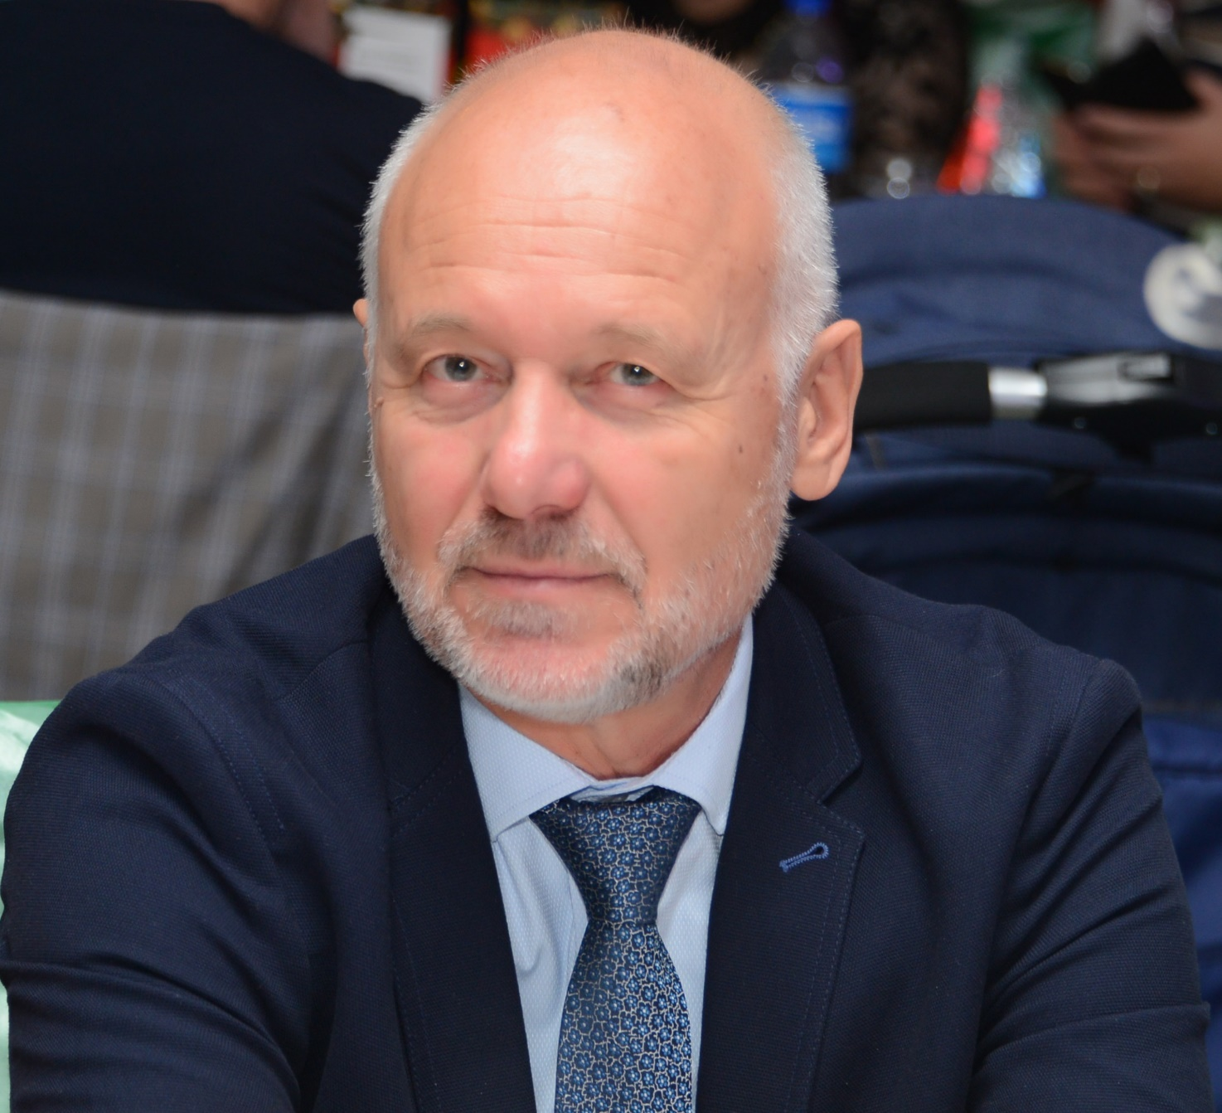
Todor Tagarev Is head chair of CMINE and full professor at the Institute of ICT of the Bulgarian Academy of Science and leads its Centre for Security and Defence Management. He is a security and defence policy-maker combining governmental experience with sound theoretical knowledge and background in cybernetics, complexity, and security studies; with considerable expertise in leading and participating in national and international research teams.

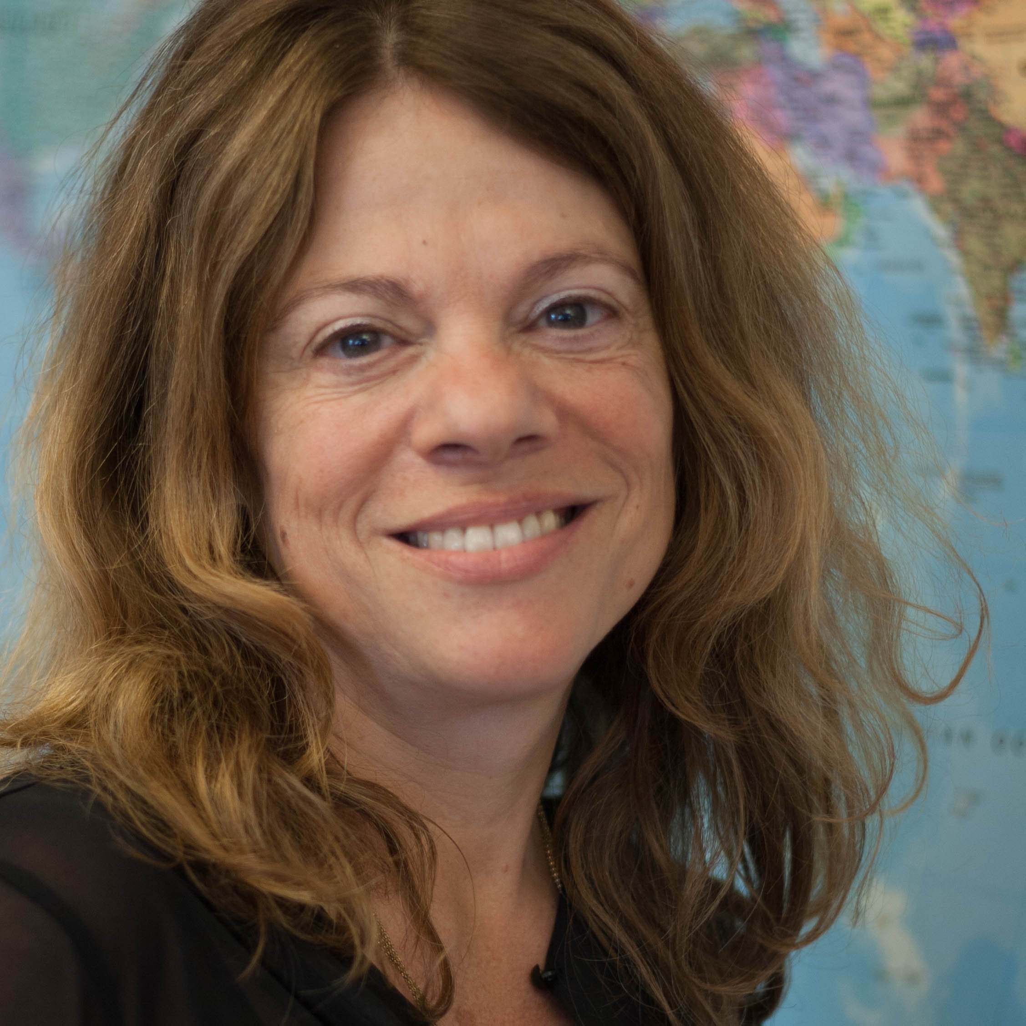
Nana Wiedemann is Head of Centre for the IFRC Reference Centre for Psychosocial Support. She sets the direction for the Centre's strategy and leads the work on its memberships services for MHPSS support to the IFRC National Societies' staff and volunteers, policy and humanitarian diplomacy for MHPSS on behalf of the Movement, the centre's research and development and innovation within the field. Nana is a licenced psychologist specialised in traumatic stress and community-based psychosocial support in humanitarian organizations.

Martha Bird and Louise Juul Hansen – Lead authors and CMINE Theme Chairs for Volunteer Management

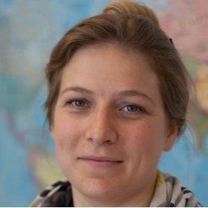
Martha Bird is Senior Consortium Lead at the IFRC Reference Centre for Psychosocial Support for the centre’s international research and innovation consortia engagements. She leads collaborative research and development of guidelines, papers and innovative resources on mental health and psychosocial support, volunteers, crisis management, climate change, migration, integration and civil society.
She holds a Master of Arts in History from the University of Copenhagen, Denmark and a Postgraduate Degree in Global Health from Manchester University, United Kingdom.
mabir@rodekors.dk

Louise Juul Hansen is Senior Communications Advisor at IFRC Reference Centre for Psychosocial Support. She has extensive experience in facilitating collaborative innovation and editing processes. Louise is an editor of several manuals and guidelines about mental health and psychosocial support, including guidelines for incorporating psychosocial support in community-based disaster response, psychological first aid and caring for volunteers. She holds a Master of Arts in Media Studies from the University of Copenhagen, Denmark.

CMINE authors for the Volunteer Management task group

Adjmal Dulloo is the Global Volunteering Coordinator at the IFRC (International Federation of the Red Cross and Red Crescent Societies). His work is in the area of volunteering development, supporting Red Cross Red Crescent National Societies to improve and modernise their volunteering practices as well as ensuring the safety and wellbeing of their volunteers. Prior to that, Adjmal has been the representative of the Volunteer Stakeholder Group to the High Level Political Forum. He also co-founded a volunteer arts education programme in the slums of Kibera entitled "Unmasking Shadows" aiming at integrating street children into society through the arts. Adjmal holds a Masters degree from the Swiss School of Management.

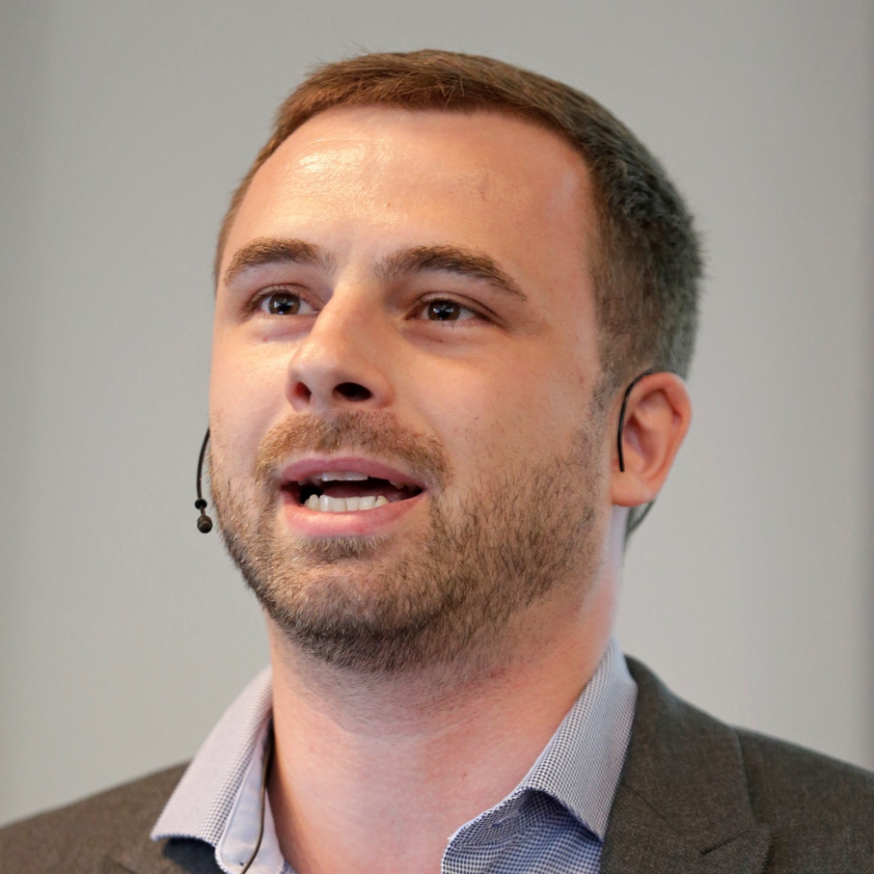
Andreas Löpsinger is Advisor on Psychosocial Support for Syrian & Iraqi Refugees and IDP for Deutsche Gesellschaft für Internationale Zusammenarbeit (GIZ) GmbH. He is currently based in Dohuk (Iraq), after having worked in Jordan and Rwanda before. Andreas is one of the co-chairs of the Inter-Agency Standing Committee (IASC) working group on staff and volunteer care, which brings together almost 30 MHPSS-experts from all over the globe who are aiming to improve the situation of staff and volunteers working in the humanitarian sector. Andreas holds a Master's Degree in International Relations & Peace and Conflict Studies at the Goethe University Frankfurt, Germany.

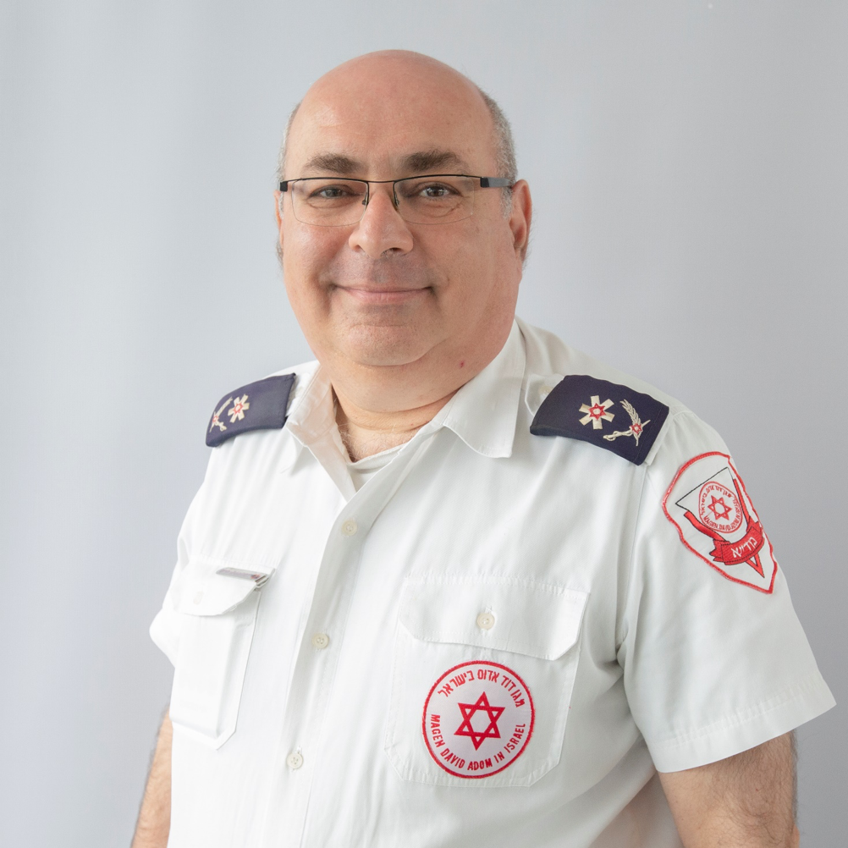
Chaim Rafalowski, M.A in public policy and administration, Tel Aviv University. He is in charge of MDA research activities, involved in several EU research projects. In those projects worked on the end-user requirements as well as on the validation of the results. Chaim was involved in the development of the 1st generation of the MDA C4I system, acts as an active dispatcher and a senior member of the MDA operations division for the last 15 years. Chaim is the Disaster Management Coordinator of MDA.

Daniel Auferbauer is a Junior Scientist at the AIT Austrian Institute of Technology, Center for Digital Safety and Security. He conducts research on the application of information and communication technology in crises and disasters. Specifically, he investigates the influence of technology on the interaction between (emergent) volunteer response and established organisations in crisis and disaster management. Daniel Auferbauer graduated from the Vienna University of Technology with a PhD in Business Informatics.

Isabel Silva is founder and volunteer coordinator at VOST (Virtual Operations Support Team) Portugal. She also acted as researcher and coordinator of volunteers in the project "Apar: Evaluation of the effectiveness of the implementation of the Peers Early Education Partnership in Portugal", a collaborative project between the Faculty of Psychology and Education Sciences of the University of Lisbon (FPCE/UL),University of Oxford-Department of Educational Studies (University of Oxford) and Interdisciplinary Center for Educational Study (CIEE/eSeL/IPL). Isabel is a licensed psychologist with specialized training in psychosocial intervention in social neighborhoods: field and team intervention and post-traumatic stress. She holds a Master degree in psychology from Lisbon University, Portugal.

Itamar Laist, M.B.A, Ben Gurion University. He is a paramedic and disaster management officer in MDA. Itamar is involved in several EU research projects.

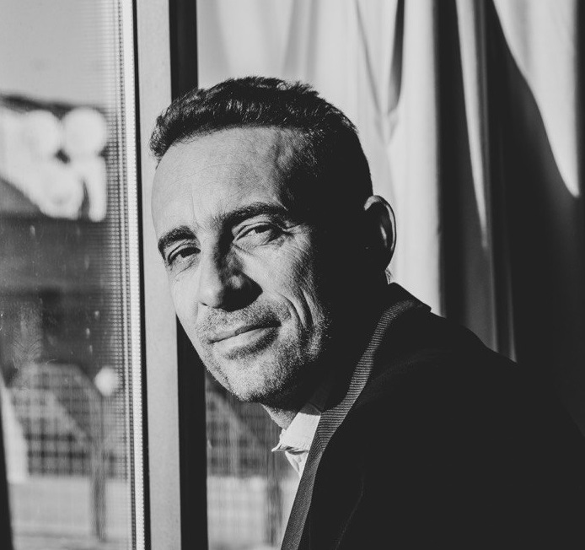
Massimo Lanfranco is Senior Programme Officer in Regione Liguria, Italy. He holds 20 years of experience in flood mitigation and disaster risk reduction, including working as a Scientific Officer at the European Joint Research Centre and engagement in several European research and innovation projects on crisis management. Massimo holds a PhD in Strategic Sciences and an M.SC in Earth Sciences. The focus of his doctoral thesis was “Integration of civil defence, civil protection and civil military cooperation during complex emergencies and all along the disaster cycle”.

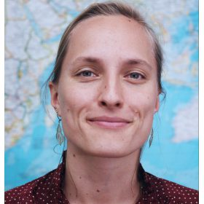
Nathalie Rigall is project assistant at the IFRC Reference Centre for Psychosocial Support and supports several of the centre's research and innovations efforts. She has experience from emergency responses in South Sudan, Lebanon and Greece, working in the sectors of camp management and camp coordination, information management, spontaneous volunteer engagement, protection and community services. Nathalie holds a Master of Global Refugee Studies Aalborg University, Copenhagen – an international MSc specialisation with a strong research component which focuses on refugees and forced migration.

Nina Baron is Senior Lecturer at the Emergency and Risk Management program at University College Copenhagen, Copenhagen, Denmark. She currently teaches and researches on problems related to climate adaptation, disaster mitigation, emergency management and risk communication. Nina is a sociologist specialized in decision-making and risk perceptions in relation to climate change and extreme weather. In her research projects, she has been focusing on barriers and possibilities in cooperation between public and private actors, with a special focus on areas outside the larger cities. Nina holds PhD in environmental sociology from Aahus University and a Master of Art in Sociology from Copenhagen University, Denmark.

Serena Tagliacozzo is a Research Fellow and Evaluation Specialist at the National Research Council (CNR) of Italy, where she is active in designing new methods and frameworks for the evaluation of EU-funded projects. She works also as Crisis Management policy consultant for the leading Italian industry in the aerospace and defence sector. Before joining the CNR, Serena gained relevant experience in the disaster risk management field through work in diverse settings, including private businesses, NGOs and policy making institutions. She holds a Ph.D. in Disaster Risk Reduction from University College London (UK) and Master and Bachelor Degrees in Psychology from University of Naples Federico II (Italy). She has presented in several international conferences and published peer-reviewed papers in leading journals.

LIST OF ABBREVIATIONS

CMINE The Crisis Management Innovation Network Europe
DRIVER+ Driving Innovation in Crisis Management
EU European Union
ICT Information and communication technology
IFRC International Federation of Red Cross and Red Crescent Societies
MHPSS Mental Health and Psychosocial Support
NGO Non-governmental organization
OCHA The United Nations Office for the Coordination of Humanitarian Affairs
UN United Nations
VOST Virtual Operational Support Team

BIBLIOGRAPHY

Aguirre, B. E., & Tierney, K. J. (2001) Testing Shibutani’s Prediction of Information Seeking Behavior in Rumor. Disaster Research Center. Newark, Delaware. Retrieved from: https://pdfs.semanticscholar.org/3dec/879555257e020241ab3c80123edaaa42764e.pdf

Auferbauer, D., Ruggenthaler, C., Czech, G., and Gojmerac, I. (2019) Taxonomy of Community Interaction in Crises and Disasters. In Zeno Franco, Jose J. González, & Jose H. Canós, eds. Proceedings of the 16th ISCRAM Conference. Valencia, Spain.

Australian Government (2015) Spontaneous Volunteer Strategy. Coordination of Volunteer Effort In the Immediate Post Disaster Stage. Retrieved from: https://files-em.em.vic.gov.au/public/EMV-web/National-Spontaneous-Volunteer-Strategy.pdf

Australian Government (2017) Australian Disaster Resilience Handbook 12 Communities Responding to Disasters: Planning for Spontaneous Volunteers (AIDR 2017) Retrieved from: https://knowledge.aidr.org.au/media/4855/aidr_handbook12_v6_webcopy01_181217.pdf

Barsky L. E., Joseph E. T., Manuel R. T., and Benigno E. A. (December 2007) Managing volunteers: FEMA’s Urban Search and Rescue programme and interactions with unaffiliated responders in disaster response. Disasters 31, 4, 495–507. Retrieved from: http://dx.doi.org/10.1111/j.1467-7717.2007.01021.x

Bordia, P., & DiFonzo, N. (2002) When social psychology became less social: Prasad and the history of rumor research. Asian Journal of Social Psychology, 5(1), 49–61. Retrieved from: https://doi.org/10.1111/1467-839X.00093

Brooks, S. K., Dunn, R., Sage, C. A. M., Amlôt, R., Greenberg, N. & Rubin, J. R. (2015) Risk and resilience factors affecting the psychological wellbeing of individuals deployed in humanitarian relief roles after a disaster. Journal of Mental Health, 24:6, 385-413.
Büscher, M., Liegl, M., & Thomas, V. (2014) Collective Intelligence in Crises. In D. Miorandi, V. Maltese, M.
Cobb, C., McCarthy, T., Perkins, A., Bharadwaj, A., Comis, J., Do, B., & Starbird, K. (2014) Designing for the deluge: Understanding & Supporting the Distributed, Collaborative Work of Crisis Volunteers. In Proceedings of the 17th ACM conference on Computer supported cooperative work & social computing - CSCW ’14 (pp. 888–899). New York, New York, USA: ACM Press. Retrieved from: https://doi.org/10.1145/2531602.2531712

Cone D., Weir S., Bogucki S. (2003) Convergent volunteerism. In Annals of Emergency Medicine, Volume 41, Issue 4, (pp. 457-462). Retrieved from https://doi.org/10.1067/mem.2003.107.

Commonwealth of Australia (2010) Australian Government. Department of Families, Housing, Community Services and Indigenous Affairs. In collaboration with Australian Red Cross. Spontaneous Volunteer Management. Resource Kit. Helping to manage spontaneous volunteers in emergencies. Retrieved from: https://www.dss.gov.au/sites/default/files/documents/05_2012/spontaneous.pdf

Dailey, D., & Starbird, K. (2017) Social Media Seamsters. In Proceedings of the 2017 ACM Conference on Computer Supported Cooperative Work and Social Computing - CSCW ’17 (pp. 1277–1289). New York, New York, USA: ACM Press. https://doi.org/10.1145/2998181.2998290

DEFRA (July 2015) Department for Environment, Food and Rural Affairs. Joint Flood and Coastal Erosion Risk Management Research and Development Programme. Spontaneous volunteers: Involving citizens in the response and recovery to flood emergencies. Flood Risk Management Division. Final report FD2666. Retrieved from: http://randd.defra.gov.uk/Document.aspx?Document=13013_FD2666_FinalReport_SpontaneousVolunteers.pdf

Deutches Rotes Kreuz (2014) Die Rolle von ungebundenen HelferInnen bei der Bewältigung von Schadenssereignissen - Teil 1. Untersuchung am Beispiel Hochwasser 2013 in Sachsen. Retrieved from: https://www.drk.de/fileadmin/user_upload/Forschung/schriftenreihe/band_1/Schriften_der_Forschung_1.1._Die_Perspektive_der_ungebundenen_Helferinnen_und_Helfer.pdf

Drabek, Thomas E. and McEntire,David A. (May 2003) Emergent phenomena and the sociology of disaster: lessons, trends and opportunities from the research literature. Disaster Prevention and Management: An International Journal 12, 2 97–112. Retrieved from: http://dx.doi.org/10.1108/09653560310474214

Griffiths, M. et al., (2018) Theme Paper 6: Trauma and Psychosocial Support. Stockholm: SRC.

Harrison, S. E., & Johnson, P. A. (2016) Crowdsourcing the Disaster Management Cycle. International Journal of Information Systems for Crisis Response and Management, 8(4), 17–40. Retrieved from: https://doi.org/10.4018/IJISCRAM.2016100102

Haworth, B. T., Bruce, E., Whittaker, J., & Read, R. (2018) The Good, the Bad, and the Uncertain: Contributions of Volunteered Geographic Information to Community Disaster Resilience. Frontiers in Earth Science, 6(November). Retrieved from: https://doi.org/10.3389/feart.2018.00183

Helsloot, Ira and Ruitenberg, Arnout (2004) Citizen response to disasters: A survey of literature and some practical implications. Journal of Contingencies and Crisis Management 12, 3, 98–111. Retrieved from: http://dx.doi.org/10.1111/j.0966-0879.2004.00440.x

Hiltz, S. R., & Plotnick, L. (2013) Dealing with Information Overload When Using Social Media for Emergency Management: Emerging Solutions. In Proceedings of the 10th International ISCRAM Conference (pp. 823–827). Baden-Baden, Germany.

Hobfoll S. E, Watson P, Bell C. C, Bryant R. A, Brymer M. J, Friedman M. J, et al. (2007) Five essential elements of immediate and mid-term mass trauma intervention: Empirical evidence. Psychiatry. No. 70:283–315.

Hughes, A. L., St. Denis, St. L. A., Palen, L., & Anderson, K. M. (2014) Online public communications by police & fire services during the 2012 Hurricane Sandy. In Proceedings of the 32nd annual ACM conference on Human factors in computing systems - CHI ’14 (pp. 1505–1514). New York, New York, USA: ACM Press. Retrieved from: https://doi.org/10.1145/2556288.2557227

Hughes, A. L., & Tapia, A. H. (2015). Social Media in Crisis: When Professional Responders Meet Digital Volunteers. Journal of Homeland Security and Emergency Management, 12(3). Retrieved from: https://doi.org/10.1515/jhsem-2014-0080

IFRC (March 2018) International Federation of Red Cross and Red Crescent Societies. Everyone Counts. Retrieved from: https://drive.google.com/file/d/1OTIlx_5jUFZxjxml1HCLh1sRTvyWC1vm/view

IFRC conference (2015) International Federation of Red Cross and Red Crescent Societies. 32nd INTERNATIONAL CONFERENCE OF THE RED CROSS AND RED CRESCENT. Geneva, Switzerland 8-10 December 2015. The safety and security of humanitarian volunteers. Resolution. Retrieved from: https://rcrcconference.org/app/uploads/2015/04/IC32-AR5-Safety-security-volunteers_EN.pdf

IFRC council of delegates (2019) International Federation of Red Cross and Red Crescent Societies. COUNCIL OF DELEGATES OF THE INTERNATIONAL RED CROSS AND RED CRESCENT MOVEMENT. Geneva, Switzerland 8 December 2019. International Red Cross and Red Crescent Movement policy on addressing mental health and psychosocial needs. RESOLUTION. Retrieved from: https://rcrcconference.org/app/uploads/2019/12/CD19-R5-Adopted-MHPSS-need-policy-draft-resolution-FINAL-EN_clean.pdf

Imperiale A.J. & Vanclay F. (2019) Command-and-control, emergency powers, and the failure to observe United Nations disaster management principles following the 2009 L'Aquila earthquake. International Journal of Disaster Risk Reduction 36, 101099.

Jennex, M. (2012) Social Media–Truly Viable For Crisis Response. In Proceedings of the 9th International ISCRAM Conference (pp. 1–5). Vancouver, Canada. Retrieved from: http://www.iscramlive.org/ISCRAM2012/proceedings/200.pdf

Kaufhold, M.-A., & Reuter, C. (2016) The Self-Organization of Digital Volunteers across Social Media: The Case of the 2013 European Floods in Germany. Journal of Homeland Security and Emergency Management, 13(1), 137–166. Retrieved from: https://doi.org/10.1515/jhsem-2015-0063

LaPiere, R. T. (1938). Collective Behavior (1st ed.). McGraw-Hill.

Lettieri, E., Masella, C., & Radaelli, G. (2009). Disaster management: findings from a systematic review. Disaster Prevention and Management: An International Journal, 18(2), 117–136. Retrieved from: https://doi.org/10.1108/09653560910953207

Liu, S. B. (2014) Crisis Crowdsourcing Framework: Designing Strategic Configurations of Crowdsourcing for the Emergency Management Domain. Computer Supported Cooperative Work (CSCW), 23(4–6), 389–443. Retrieved from: https://doi.org/10.1007/s10606-014-9204-3

Majchrzak, A., & More, P. H. B. (2011). Emergency! Web 2.0 to the rescue! Communications of the ACM, 54(4), 125. Retrieved from: https://doi.org/10.1145/1924421.1924449

Meier, P. (2012) Crisis Mapping in Action: How Open Source Software and Global Volunteer Networks Are Changing the World, One Map at a Time. Journal of Map & Geography Libraries, 8(2), 89–100. Retrieved from: https://doi.org/10.1080/15420353.2012.663739

Mukkamala, A., & Beck, R. (2017) Social media for disaster situations: Methods, opportunities and challenges. In 2017 IEEE Global Humanitarian Technology Conference (GHTC) (pp. 1–9). IEEE. Retrieved from: https://doi.org/10.1109/GHTC.2017.8239277

Nielsen, Laurits Rauer (2019) Embracing and integrating spontaneous volunteers in emergency response – A climate related incident in Denmark. Safety Science.

Oh, O., Agrawal, M., & Rao, H. R. (2013) Community Intelligence and Social Media Services: A Rumor Theoretic Analysis of Tweets During Social Crises. MIS Quarterly, 37(2), 407–426. Retrieved from: https://doi.org/10.25300/MISQ/2013/37.2.05

Paciarotti, C., Cesaroni, A. & Bevilacqua, M. (2018) The management of spontaneous volunteers: A successful model from a flood emergency in Italy. International Journal of Disaster Risk Reduction, 31, 260-274.

Palen, L., Vieweg, S., Liu, S. B., & Hughes, A. L. (2009) Crisis in a Networked World: Features of Computer-Mediated Communication in the April 16, 2007, Virginia Tech Event. Social Science Computer Review, 27(4), 467–480. Retrieved from: https://doi.org/10.1177/0894439309332302

Roine, Johansson and Kvarnlöf, Linda. (Under review) Emergence: Understanding the assembling process of volunteers during disasters. Manuscript submitted to Symbolic Interaction.

Roth, F., & Prior, T. (2019) Utility of Virtual Operation Support Teams: an international survey. Australian Journal of Emergency Management, 34(2), 53–59. Retrieved from: https://doi.org/10.3929/ethz-b-000347723

Shklovski, I., Palen, L., & Sutton, J. (2008) Finding community through information and communication technology in disaster response. In Proceedings of the ACM 2008 conference on Computer supported cooperative work - CSCW ’08 (p. 127). New York, New York, USA: ACM Press. https://doi.org/10.1145/1460563.1460584

Simon, T., Goldberg, A., & Adini, B. (2015) Socializing in emergencies - a review of the use of social media in emergency situations. International Journal of Information Management, 35(5), 609–619. Retrieved from: https://doi.org/10.1016/j.ijinfomgt.2015.07.001

Shaw D. Preece G., Hayashi H., (2015) Application of the Viable System Model to analyse communications structures: A case study of disaster response in Japan. In European Journal of Operational Research, Volume 243, Issue 1, (pp. 312-322). retrieved from: https://doi.org/10.1016/j.ejor.2014.11.026.

Starbird, K., & Palen, L. (2011) “Voluntweeters”: Self-organizing by Digital Volunteers in Times of Crisis. In Proceedings of the 2011 annual conference on Human factors in computing systems - CHI ’11 (pp. 1071–1080). New York, New York, USA: ACM Press. Retrieved from: https://doi.org/10.1145/1978942.1979102

Starbird, K. (2012) What “Crowdsourcing” Obscures: Exposing the Dynamics of Connected Crowd Work during Disaster. Collective Intelligence 2012 Proceedings, (February), 1–8. Retrieved from: https://doi.org/arXiv:1204.3342

Starbird, K., & Palen, L. (2013). Working and sustaining the virtual “Disaster Desk.” In Proceedings of the 2013 Conference on Computer Supported Cooperative Work (pp. 491–502). New York, New York, USA: ACM Press. Retrieved from: https://doi.org/10.1145/2441776.2441832

St. Denis, L. A., Hughes, A. L., Palen, L., Ann, L., Denis, S., & Hughes, A. L. (2012) Trial by Fire : The Deployment of Trusted Digital Volunteers in the 2011 Shadow Lake Fire. Proceedings of the 9th International ISCRAM Conference, (April), 1–10.

Stieglitz, S., Bunker, D., Mirbabaie, M., & Ehnis, C. (2018) Sense-making in social media during extreme events. Journal of Contingencies and Crisis Management, 26(1), 4–15. Retrieved from: https://doi.org/10.1111/1468-5973.12193

Thormar, SB., Gersons, BPR., Juen, B., Djakababa, MN., Karlsson, T., Olff M. (2012) The impact of disaster work on community volunteers: A longitudinal study on the role of resource loss, peri-traumatic distress and sleep quality on post-traumatic stress disorder symptoms and subjective health after the Yogyakarta earthquake. Social Psychiatry and Psychiatric Epidemiology.

Twigg, John and Mosel, Irina (2017) Emergent groups and spontaneous volunteers in urban disaster response. Environment and Urbanization 29, 2, 443–458. Retrieved from: http://dx.doi.org/10.1177/0956247817721413

UN (2015) United Nations. Resolution adopted by the General Assembly on 17 December 2015. 70/129. Integrating volunteering into peace and development: the plan of action for the next decade and beyond. Retrieved from: https://www.un.org/en/ga/search/view_doc.asp?symbol=A/RES/70/129
UNDRO (1982). Shelter After Disaster: Guidelines for Assistance, Office of the United Nations Disaster Relief Co-Ordinator, Geneva. Retrieved from: https://reliefweb.int/report/world/shelter-after-disaster-guidelines-assistance
UNV (2018) United Nations Volunteers. 2018 STATE OF THE WORLD'S VOLUNTEERISM REPORT. The thread that binds. Volunteerism and community resilience. Retrieved from: https://www.unv.org/sites/default/files/UNV_SWVR_2018_English_WEB.pdf

Voida, A., Yao, Z., & Korn, M. (2015) (Infra)structures of Volunteering. In Proceedings of the 18th ACM Conference on Computer Supported Cooperative Work & Social Computing - CSCW ’15 (pp. 1704–1716). New York, New York, USA: ACM Press. Retrieved from: https://doi.org/10.1145/2675133.2675153

Waldman, S., & Kaminska, K. (2015) Connecting emergency management organizations with digitally enabled emergent volunteering Literature review and best practices.

Whittaker J., McLennan, B. and Handmer, J. (2015) A review of informal volunteerism in emergencies and disasters: Definition, opportunities and challenges. International Journal of Disaster Risk Reduction 13, 358–368. Retrieved from: http://dx.doi.org/10.1016/j.ijdrr.2015.07.010

Zettl V., Ludwig, T., Kotthaus, C., and Skudelny, S. (2017) Embedding unaffiliated volunteers in crisis management systems: Deploying and supporting the concept of intermediary organizations. In Tina Comes, Frédérick Bénaben, Chihab Hanachi, Matthieu Lauras, & Aurélie Montarnal, eds. Proceedings of the 14th ISCRAM Conference. Albi, France, 421–31.

In the sense of having been established before the onset of the event and having a dedicated role to play in formalised crisis and disaster response procedures; and in the sense that they are recognised formally in national or international planning for crisis and disaster management.
Though primarily observed during the immediate response phase (Harrison & Johnson, 2016), as this is the time when data collation and information processing is needed most
However, there are no reports of this practice being used widely at the time of writing.

